Term 4 for EYFS
- Know the days of the week in order
- Identify one more and one less than any number (to 10)

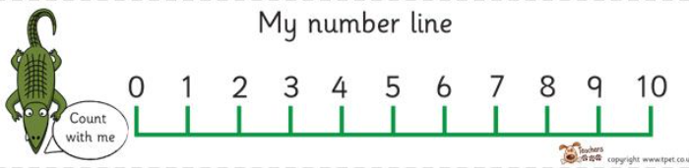
Use the number line to find a number. Ask your child, “ What is one more ?“
“ What is one less ? “ Allow your child to use the number line to check until they are confident doing this without the number line.
- Count back from 20 to 0
Practise counting backwards daily as this is a tricky skill for many children. Children often confuse 13 and 15 so watch out for this.
- Count to 50

Children do not need to write numbers to 50 at this stage but benefit from counting small objects up to 50. Once children are able to count to 30 they quickly pick up the number patterns for number 30 – 50. The trickiest part is the transition over the 10’s boundary ( 19 – 20 ; 29 – 30 ; 39 – 40 etc)
Daily practise is the key to this skill and can be incorporated into play.

