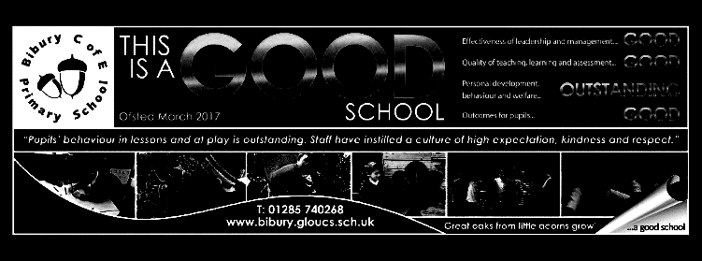

Mighty Oaks Term 4 20-2021

**Welcome back to term 4, which will return to ‘normal’ on March 8th, when we look forward to welcoming you all back to school. Yippee!**

When children have all settled back into school, we will carry out some assessments to identify whether any areas of learning have not ‘stuck’ over the last time and then spend some extra time revisiting areas of weakness, particularly in English and Maths.

All pupils have new reading targets this term, so please encourage them to read daily, record in their journals and take quizzes for any books on Accelerated Reader, or write book reviews for those that are not.

For this term, homework for all will consist of Spellings, Reading and Mathletics. Your child may be given additional tasks to practise specific skills. Please also help them to learn their Key Instant Recall Facts for maths and encourage them to use their Knowledge Organisers, which they will be given when they return.

**English**

We will begin with a narrative unit based on The Fantastic Flying Books of Mr Morris Lessmore – a book which has been made into a short film.

We will then go on to look at techniques in persuasive writing.

As part of this we will explore aspects of writing including:

Adverbials, complex sentences, simile, metaphor, personification, alliteration, repetition, pun, rhyme.

We will be considering how the language choices match the purpose of the writing and also be using a range of punctuation to express ideas.

We will continue with the story ‘Letters from the Lighthouse’ for a few more weeks and then in reading we will be spending time looking at ways of structuring responses to questions about texts.

We will also continue with spelling and handwriting.

**Mathematics**

When the children return to school, we will be spending some additional time finding out whether there are any areas of maths that they have had difficulty understanding or retaining and then do some consolidation activities in addition to the planned work below.

|  |
| --- |
| Year 5  Statistics – charts and line graphs  Decimal numbers and their links with fractions  Round, order and compare decimals  Understand and find percentages  Time and timetables  Year 6  Area and perimeter. Area of triangles and quadrilaterals  Volume  Ratio  Percentages  Timetables |

**Science ‘We’re evolving’.**

This term we will be exploring inheritance and evolution.

We will learn about how different characteristics are passed from parent to offspring and how some characteristics make it more likely for the young to survive (survival of the fittest).

We will also be looking at adaptations that plants and animals have that help them to survive in different habitats.

We will also explore the evidence that supports the theory of evolution.

See the knowledge organiser for more details.

**Topic –The Americas**

The children will going on a ‘Great American Road Trip’, learning about physical and environmental features of the continents and developing their mapping skills

**R.E.**

What do Christians believe Jesus did to save people?

Exploring the Easter story and the deeper meanings that Christians draw from this.

**P.S.H.E**

**Being my best.** We will consider emotional and physical wellbeing, exploring aspirations and managing risk. We will also learn some basic first aid.

.

**DT**

We plan to have a DT project near the end of the term to make electrically powered models.

**P.E**

Tchukball

Team building

Gymnastics

**Music**

Music of the Americas