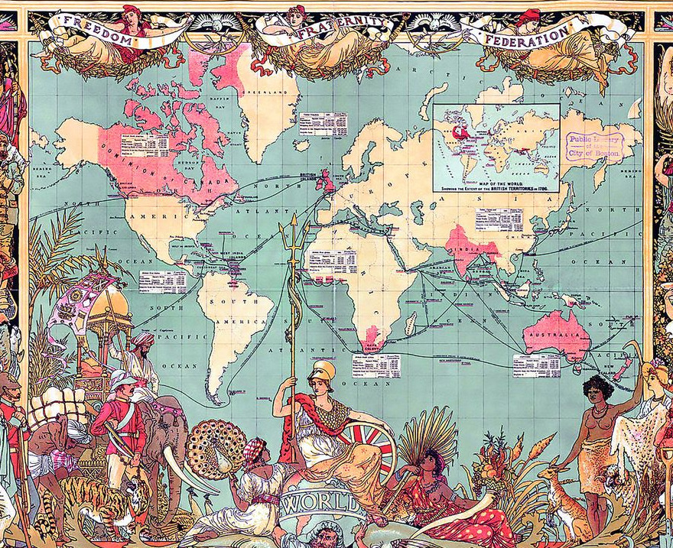
History Term 2 Knowledge Organiser – What makes people go on a journey?
Key journeys:
Sir Walter Raleigh. Queen Elizabeth I granted him a Royal Charter which permitted him to explore, rule and colonise any ‘remote, heathen and barbarous lands, countries and territories not actually possessed of any Christian prince, nor inhabited by Christian people.’

The Titanic and the emigration of the Irish in 1912 - Of the 123 passengers boarding the ship at Cobh in County Cork, only 44 survived the sinking of the ship.

The Kindertransport - A programme which brought almost 10,000 (mostly Jewish) children to Britain from Central Europe between December 1938 and the outbreak of the Second World War in September 1939.

Key Vocabulary
Journey | An act of travelling from one place to another.
Migration | Movement of people to a new area or country in order to find work or better living conditions.
Emigration | The act of leaving one's own country to settle permanently in another; moving abroad.
Immigration | The action of coming to live permanently in a foreign country.
Refugee | A person who has been forced to leave their country in order to escape war, persecution, or natural disaster.
Explorer | A person who travels in search of something.
Migrant | A person who moves from one place to another, especially in order to find work or better living conditions.
Invader | A person or group that invades a country, region, or other place.
Discrimination | The unjust treatment of different categories of people, especially on the grounds of race, age, gender, or disability.
Kindertransport | The operation to evacuate Jewish children from Nazi-controlled areas of Europe to the United Kingdom between 1938 and 1940.
Voyage | A long journey involving travel by sea.
The Windrush | The British ship that carried people emigrating from the Caribbean to Britain in 1948.
Titanic | A luxury steamship that sank in the early hours of April 15, 1912.

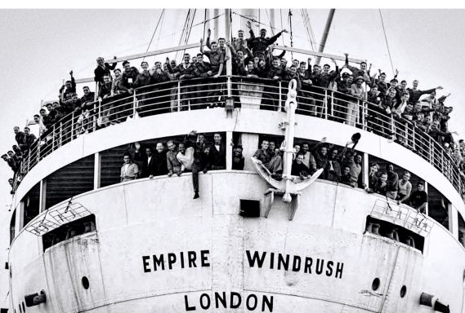
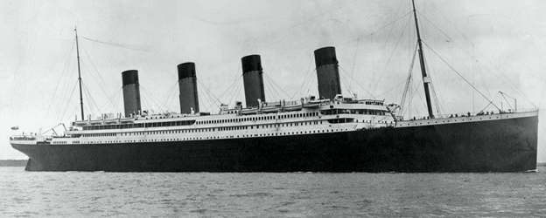
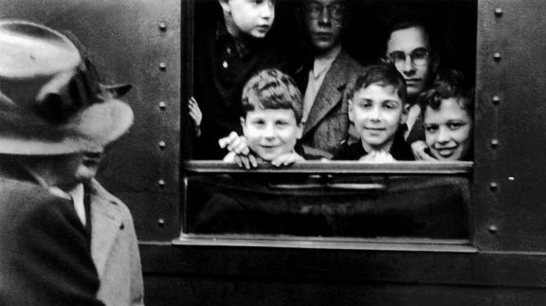
The Empire Windrush is best remembered for bringing one of the first large groups of West Indian immigrants to the UK. This is because, in 1948, the British Nationality Act allowed those people living in the Commonwealth full rights of entry and settlement. This gave people from the West Indies the opportunity to live in the UK.

