Key Vocabulary
Allah | The Arabic word for God – used by Muslims
Tawhid | Belief in the oneness of God
Qur’an | The Muslim’s holy book
Muhammad | The main prophet of Islam
Mosque | The Muslim place of worship
Ramadan | A period of fasting during the ninth month of the Islamic Lunar Calendar
Eid ul – Fitr | The celebration of the end of Ramadan
Mecca | Holy City in Saudi Arabia. The direction in which Muslims point their prayer mat.
Muslim | A person that practices Islam.
Fasting | A prolonged period of not eating or drinking.
Islam | The world’s second -largest religion with over 1.9 billion followers.
Prophet | A messenger sent from God.
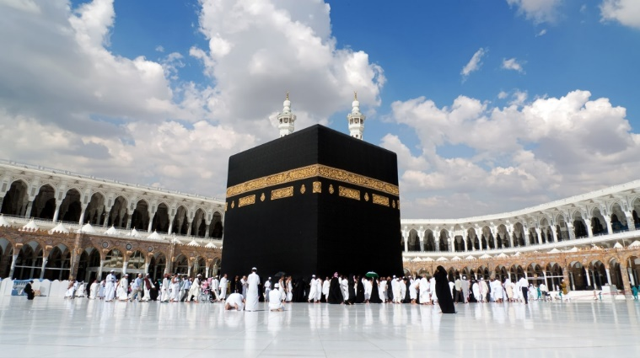
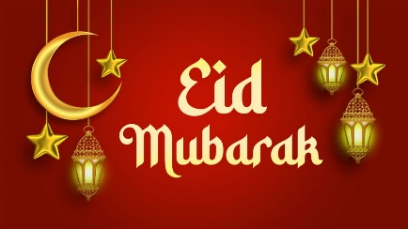
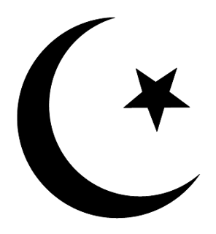
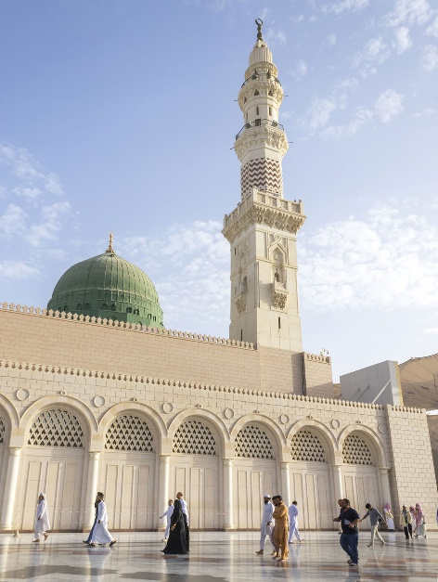
Outcomes
Identify some beliefs about God in Islam, expressed in Surah 1
Give examples of worship in Islam (e.g. prayer, fasting, celebrating) and describe what they involve.
Make links between Muslim beliefs about God and a range of ways in which Muslims worship (e.g. in prayer and fasting, as a family and as a community, at home and in the mosque)
How do festivals and worship show what matters to a Muslim?
Term 4 – Knowledge Organiser

