Knowledge organiser term 5 History of Bibury
Key Vocabulary |  |  |  | 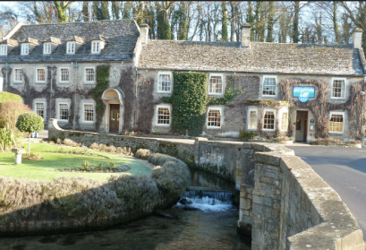  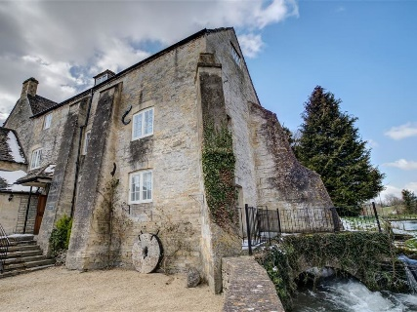  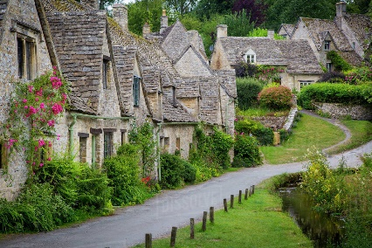  The Swan – built as a coaching inn in the 18th Century.  Arlington Mill – built in the 17th Century for fulling wool.  Arlington Row – originally built to store wool in the 14th Century
chronology | the organisation of dates and events in time order
census | Data collected by the government every ten years since 1801 about the members of households.
settlement | A place where people live
fulling mill | A mill where woollen cloth was cleaned of oil and dirt and made thicker by cleaning and pounding.
sources | Things which can be used to tell us about history. Primary sources come from the historical period and could be buildings, objects, pictures or writing. Secondary sources are books that have been written about these things by historians (historians usually study primary sources when they write their books).
Romano-British settlements | These were settlements made after the Roman invasion of Britain, usually small enclosed villages of huts. Evidence of these settlements is now usually only in the shape of the earth - for example round indentations in the ground where buildings would have stood.
Roman Villa | A large country house built and occupied during Roman times.
Anglo-Saxon | The period of British history from the start of the invasion of people from Europe - the Angles, Saxons and Jutes in about 600 A.D. This continued in the South West of England until 1066, when the Normans invaded.
Bibury Timeline
Between 800 B.C. and 43 A.D Iron-age settlement at Ablington | Between 43 and 410 A.D. Romano-British settlement on the Coln | 8th Century - estates given by Bishop Wilfrith of Worcester to Earl Leppas and his daughter Beaga. The church was first built. | 14th Century  Arlington cottages first built and used to store wool by monks of Osney Abbey | 17th Century  Arlington Row became weavers cottages. The mill was built for fulling the wool. | 18th Century The Swan Inn was built as a stopping point for coaches on the Oxford -Cirencester road | 1850s  Bibury School was built | 1902 The trout farm was established in Bibury - it is the oldest trout farm in England.

