What Kind of World Did Jesus Want?
Term 5 – Knowledge Organiser
Key Vocabulary
Gospel | The record of Jesus’ life and teachings in the first four books of the New Testament. These are titled; Matthew, Mark, Luke, and John.
Disciple | A follower of Jesus during his life. Especially refers to the 12 disciples of Jesus.
New Testament | The second part of the Bible that centers around the life and teachings of Jesus.
Verse | A short part of a chapter in the Bible.
Parable | A story used to highlight a moral lesson.
Miracle | An extraordinary event that cannot be explained by nature or science.
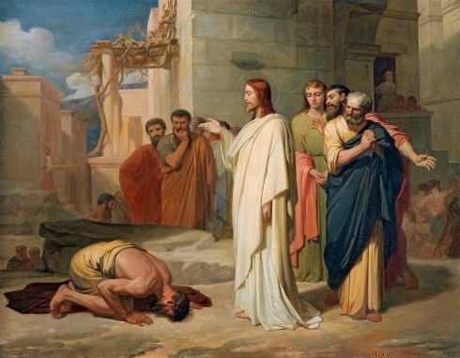
Outcomes
Identify texts that come from a Gospel, which tells the story of the life and teaching of Jesus.
Suggest ideas and then find out about what Jesus’ actions towards outcasts mean for a Christian.
Give examples of how Christians try to show love for all, including how Christian leaders try to follow Jesus’ teaching in different ways.
Make links between the importance of love in the Bible stories studied and life in the world today.

Key Gospels
Jesus and the Leper | Mark: 1:40 - 44
The Good Samaritan | Luke: 10:25 - 37
The Tax Collector | Luke: 19:1 - 10
The Widow’s Offering | Luke: 21:1 - 4
