Year 2
Term 6 KIRFS

- Know multiplication and division facts for the 2, 5 and 10 times tables

Children have made progress with learning their multiplication tables but the division facts are not secure yet. Please practise daily

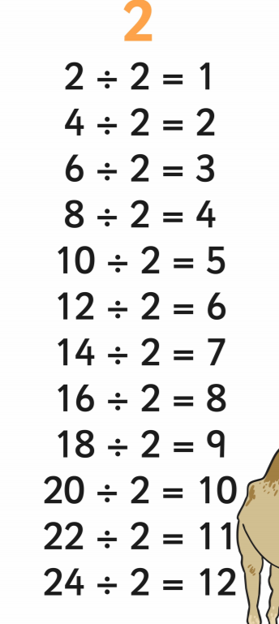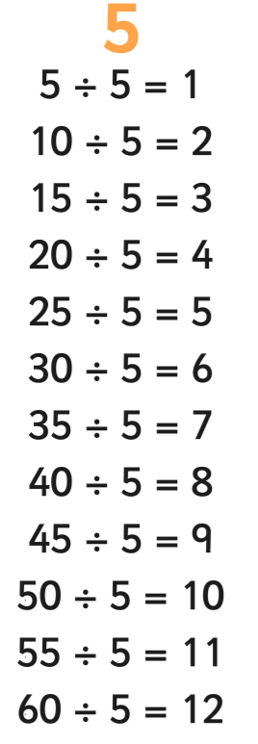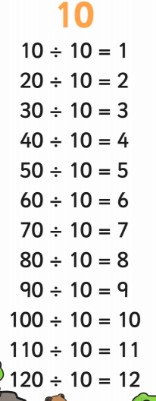
- Know doubles and halves to 20

Again flashcards are useful here Double 11 on one side with the answer 22 on the back
- Know the number of hours in a day. ( There are 24 hours in one day)
- Know the number of minutes in an hour. ( There are 60 minutes in one hour)
- Practice telling the time every day

