Term 5 Key Instant Recall Facts for Year 3 | Key Instant Recall Facts to Revise from Year 2
- To measure mass by reading scales in grams and kilograms.  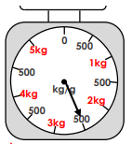  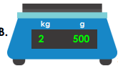  - To measure capacity by reading scales in millilitres and litres.  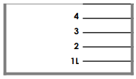  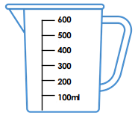  - To recognise pounds and pence and add or subtract money.  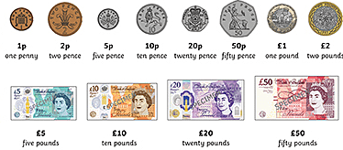  - To convert between pounds and pence using the knowledge that £1 is 100 pence.  = 100 x | 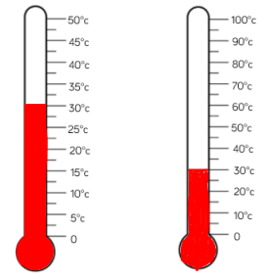  - To count up in 2s, 5s and 10s to read scales on jugs and thermometers.  - To count in pence and pounds.

