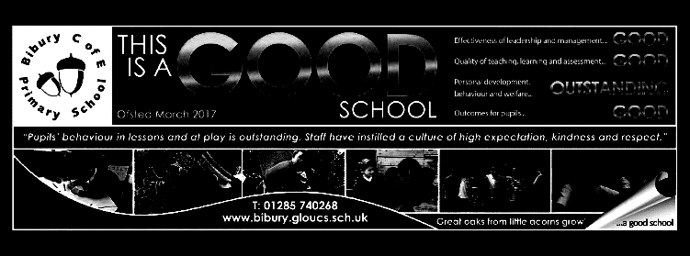

Dear Parents,

Welcome back to term 4, as Spring hopefully puts in an appearance. We begin the term with our celebration of World Book - this year with a focus on poetry.

We are also pleased that the Nature Quiz run by Gloucestershire Wildlife Trust has recommenced and look forward to playing our first round match against Southrop this term. I know that our dedicated group of quizzers have been revising in readiness.

Our PE Day returns to Thursday this term, with French moving to Friday afternoon.

Mrs. Davies

Mighty Oaks Term 4 2021-22

**Mathematics**

|  |
| --- |
| Calculate percentages of amounts (for year 6 also calculate whole amounts where the percentage is given)  **Year 5**  **Decimals**  Year 5 will complete this unit, rounding and ordering decimal numbers  **Percentages**  Understand percentages and the link with fractions.  **Area and perimeter**  Find the area and perimeter of rectangles, compound and irregular shapes  **Statistics**  Create and interpret line graphs and interpret tables, including timetables  **Year 6**  **Percentages (completing unit)**  Calculate percentages of amounts and calculate whole amounts where the percentage is given.  **Algebra**  creating formulae, solving equations and finding possibilities.  **Ratio**  Understand the language and symbol of ratio. Solve ratio and proportion problems and problems involving scale factors.  Year 6 will also continue with Mrs. Worthington weekly. This term they will focus on position and direction and statistics.  Maths skills sessions will reinforce key areas of arithmetic. |

**English**

Our writing focus for the first part of the term is ‘Mystery’. We will be looking at the key features of a traditional mystery story, with a focus on the story plot and showing characterisation through speech and action. Our writing will be based on short stories from the book ‘The Very Merry Murder Club’. For the second part of term, we will have a unit of poetry writing, linked with our work in geography.

Our key grammar and punctuation skills for term 4 are:

* Use dashes and brackets for parenthesis
* Include embedded clauses for precision and economy
* Use a variety of verb forms for effect (perfect, continuous, passive and modal verbs)
* Use the subjunctive form of verbs for formality

We will also be working on developing our spelling and handwriting skills through weekly lessons/daily tasks. The spelling pattern for each week will provided for homework and set as practice on spelling shed.

We will continue with our reading comprehension sessions. This term we will be focussing on non-fiction and poetry, as well as using our mystery story.

**Science ‘Staying Alive’.**

This term, we will be learning about the human body. After revising the function and position of the main internal organs, we focus on the circulatory system. We will learn about the function of the heart and blood and how blood is transported around the body. We will investigate pulse and breathing rates.

In addition, we consider what is needed to keep the body healthy and will look at historical data to consider the effects of nutrition on health. This work links very closely with our RSHE, where we also focus on keeping healthy.

**Topic –Geography - Rivers and the Water Cycle**

We begin by revising the water cycle before looking at how water travels through the ground and into streams and rivers. We then look at the journey of a river from source to mouth, focussing on the River Thames. We will also explore the part that rivers play in shaping the landscape, for example the formation of river valleys and how rivers are used by people. Using Ordnance Survey maps, we will look at our local river systems and will be carrying out a field study on the River Coln in Fairford Park.

**R.S.H.E**

**Being my best**

In close links with our science, we begin by looking at what is health and what is unhealthy for the body - considering diet, exercise and drugs such as nicotine and alcohol. We then consider how to foster our own strengths and talents. We think about who can help us keep safe and healthy and look at how the portrayal of celebrities in the media can be misleading. Finally, we will learn how to react in a medical emergency.

**R.E.**

**Why is the Torah important in Judaism?**

We consider the question ‘Who is Jewish?’ before learning about the 2 key branches of Judaism - orthodox and progressive. We learn about the importance of the Torah and how this is venerated.

We then look at rules for living including rules rules about kosher food and what is not permitted on the sabbath. Finally, we learn about the key features of a Jewish synagogue and what happens during services.

.

**Music**

This term we will all be learning to play the recorder and to read music. We will focus on the notes B, A and G, with crotchets, minims, semibreves and quavers, working on our ensemble playing.

We will also learn to sing 3 songs and will use untuned percussion, glockenspiels and recorders to improvise and play along with these.

On 24th March, we will join a live online workshop with the London Sinfonietta from the Royal Festival Hall.

**DT**

**Mechanised Non-Fiction Book**

Our DT unit this term will explore different types of mechanisms in non-fiction books. The children will carry out research into existing products before they design, make and evaluate their own mechanised non-fiction book. Their book will teach the reader about one of the topics being taught this term in Science or Geography: the digestive system or rivers and the water cycle. Their book will include linkages and levers to make their book as interactive and engaging as they can.

**P.E**

Dance – control, co-ordination and sequences of movement.

Team ball games and how to work as a team.

**Computing** **Touch Typing and Text Adventures**

Mighty Oaks will cover two topics in computing this term. The first will be revisiting and developing touch typing skills to improve children's posture and use of specific fingers for specific keys to allow for faster typing.

The second topic explores how to make a text adventure game that allows the player to choose their actions and outcomes. Children will learn how to design, create and debug their own games as well as playing and evaluating their classmates’ creations.