WHAT WOULD JESUS DO? Knowledge Organiser Term 5
Key Vocabulary |  | What would Jesus do bracelets  These bracelets are worn by some Christians as a reminder to them to think ‘what would Jesus do’ in certain situations. It is their ‘foundation’ upon which they make their decisions. Such as moral choices, prayer, health and how to make a better world. |  | Jesus said the two greatest Commandments are to love God and to love your neighbour (Matthew 22:36–40)
Restoration | Returning something to what it was before
Foundation | An underlying basis or principle
Parable | An earthly story with a heavenly meaning
Denial | Saying something is not true
Gospels  (gospel means ‘good news’) | The first four books in the New Testament. Their titles are Matthew, Mark, Luke and John. The main message of these books is the life of Jesus and what he did here on earth and what he said.
Ethical dilemma | A moral choice has to be made between right and wrong | Key Knowledge
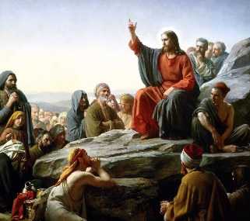  The Sermon on the Mount: Matthew 5–7 This text is an important part of Jesus’ teachings about how to live. It combines spiritual ideas with ethical practice. The Gospels teach that God can strengthen and equip those who wholeheartedly trust and follow Jesus. |  | - Christians believe the good news is not just about setting an example for good behaviour and challenging bad behaviour: it is that Jesus offers a way to heal the damage done by human sin  - Christians see that Jesus’ teachings and example cut across expectations — the Sermon on the Mount is an example of this, where Jesus’ values favour serving the weak and vulnerable, not making people comfortable. | - Christians believe that Jesus’ good news transforms lives now, but also points towards a restored, transformed life in the future.  - Christians believe that they should bring this good news to life in the world in different ways, within their church family, in their personal lives, with family, with their neighbours, in the local, national and global community.
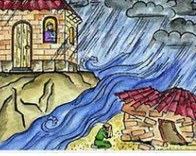  The Wise and Foolish Builders: Matthew 7:24–27 This parable shows that ‘foundations’ matter. Those who follow what Jesus said, have built firm foundations. For Christians this means trusting God, praying humbly, giving generously, forgiving and accepting forgiveness, living in a way that shows love of God, neighbour and self. |  | 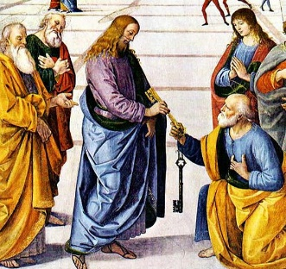  Peter’s Denial of Jesus and Restoration  Matthew 26:69-75 and John 21  The first extract shows how Peter denied that he knew Jesus after he was arrested. The reading in John shows that after his resurrection, Jesus chose Peter to spread the Christian message. These stories illustrate for Christians how Jesus showed a model of forgiveness.

