EYFS
Term 5 KIRFS ( Key Instant Recall Facts)
- Know the months of the year in order.
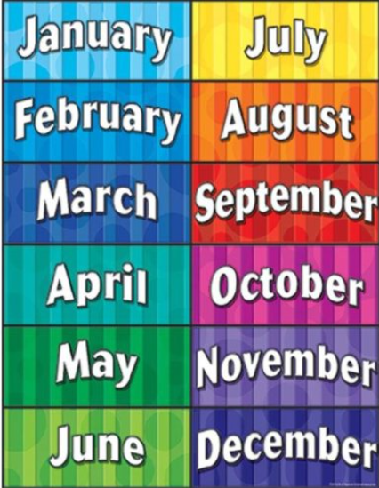
- Identify one more and one less than any number (to 20)

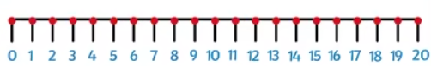
- Count to 20 and back

- Read and write numbers from 1 to 20 in numerals

