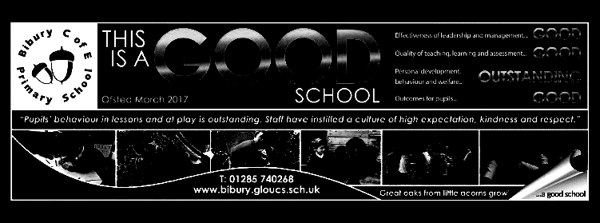

Dear Parents,

Welcome back to a short and very busy term 5. This term sees the return of SATs tests for year 6 in our third week, so we will spend some time preparing for these so that the pupils feel as comfortable as possible when tackling them. We’ll try to make the week more fun by providing year 6 breakfasts (toast and cereal) each morning. We then look forward to our residential visit in week 4 to the Wilderness Centre, which should be the highlight of the term. We also have a STEM workshop organised through the Fairford RIAT, where the winners of the challenge will go on to take part in the finals at the show on the last Friday of next term.

Our PE Day returns to Friday this term, with swimming in the afternoon and French moving to Monday afternoon.

Mrs. Davies

Mighty Oaks Term 5 2021-22

**English**

Our writing focus for the first part of the term is ‘Stories with a moral’. We will explore the themes in some of Aesop’s fables and re-write one of these in a modern setting.

For the second part of the term, we will look at explanatory writing to answer the question ‘How?’ or ‘Why?’. This will be linked with our work in science and topic.

We will continue with our reading comprehension sessions. This will involve year 6 practising SATs papers to gain a better insight into the type of question posed and how to tackle these in the time allowed.

We will also be reinforcing key grammatical features including:

* Identifying different types of noun
* Identifying adjectives and expanded noun phrases
* Identifying and naming different forms of verb
* Identifying main and subordinate clauses
* Identifying conjunctions and adverbs

Our weekly spelling continues.

**Mathematics**

|  |
| --- |
| Calculate percentages of amounts (for year 6 also calculate whole amounts where the percentage is given)  **Year 5**  **Statistics**  Interpret and create line graphs. Interpret timetables, calculating intervals of time.  **Decimals**  Calculating with decimals -adding and subtracting decimals where they have different amounts of digits after the decimal point.  Multiplying and dividing decimals by 10,100 and 1000.  **Year 6**  **Ratio and proportion**  Solve ratio and proportion problems and problems involving scale factors.  **Geometry -**  Translating and reflecting shapes using 4 quadrants  Constructing shapes with given angles and dimensions  Year 6 will also continue with Mrs. Worthington focussing on shape and angles and complete SATs practice papers in preparation for their tests.  Maths skills sessions will reinforce key areas of arithmetic. |

**Science ‘Circle of Life.**

This term, we will be learning about how organisms reproduce. We will look at different types of reproduction in plants - pollination and seed production, bulbs, runners, tubers. We will compare the life cycle of different animals particularly focussing on those that undergo metamorphosis. As part of this study, we will (hopefully) hatch some butterflies so that we can closely observe the changes from caterpillar to cocoon to butterfly.

We will also be considering the way in which different animals reproduce and the number of young that are spawned, thinking about the reasons for this.

**Topic –History: Why should Bibury be preserved?**

We are focussing on the history of the locality in this short term, looking at key periods and buildings in Bibury. We will consider why people chose to settle in Bibury, looking at the geographical features and then work our way backwards in time, looking at a Victorian Census, learning about the woollen industry, the history of the church and finally back to the settlements in the Iron Age and Roman periods. We hope to include a trip to explore more evidence of Roman occupation in the area.

**R.S.H.E**

**Rights and Responsibilities**

We will explore social media platforms, thinking about why people may choose to give a false account of themselves, in order to recognise that the online portrayal is not a true reflection of real life.

We then look at money - saving money, spending it wisely and an understanding of interest.

We will then look at jobs and taxes, and how taxation funds public services.

Finally, we will learn about the democratic process in Britain and how laws are passed by parliament.

**Art - Printmaking**

This term in art, Oaks and Mighty Oaks will be exploring printmaking. We will be learning about famous artists, such as William Morris and Henri Matisse, to understand how to create a range of different and visually exciting prints that reflect the nature around us in spring. Among the styles of printing we will be learning how to do are collograph prints and relief printing using Styrofoam tiles. Over the course of the 5 week term, children will build up their technical skills but also develop their ability to adapt and refine their work based on their evaluations of previous lessons.

**Music**

We will continue to learn the recorder this term, focussing particularly on reading and writing musical notation to include semibreves, minims, crotchets and quavers, using ‘march’ time and ‘waltz’ time. We will be composing our own simple melodies and adding lyrics to turn these into songs, building these up with the use of additional instrumentation. We will also be singing.

We have another livestreamed concert arranged for Wednesday, 18th May - this time with the Bournemoth Symphony Orchestra, who are presenting a concert entitled ‘Midnight Magic’.

**R.E.**

**What would Jesus do?**

By exploring different texts in the bible, we consider the way that Christians try to follow Christ’s example in the way that they live their lives.

The key texts that we will be using are:

The Sermon on the Mount

The parable of the wise and foolish builder

Peter’s denial of Jesus and later Restoration.

.

**Computing - 3D Modelling**

Mighty Oaks will be designing 3D models to fit a certain criteria this term. They will be introduced to new software on Purple Mash and explore how to move points on a 3D model to alter the shape and purpose. Over the term, children will create several different models which they must evaluate and refine before submitting their final design.

**P.E**

With the weather improving, the children will be playing summer ball games and beginning to prepare for athletics (Sports Day is at the start of next term). Swimming also resumes on Friday afternoons.