HOW DOES WATER GO ROUND AND ROUND? RIVERS AND THE WATER CYCLE
Key Vocabulary |  | 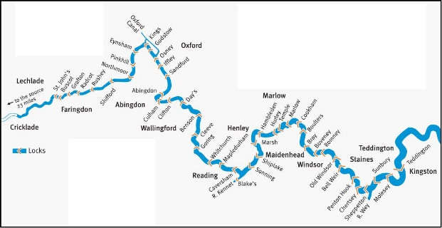  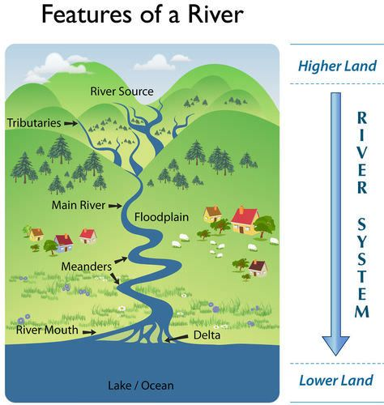  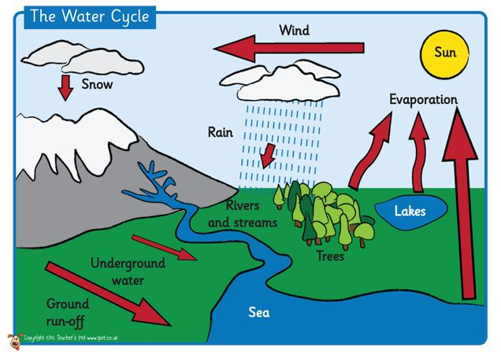 | Key knowledge and understanding
Evaporation | Water becoming a gas (water vapour). |  | - Wherever rainfall lands the water moves downhill.  - From a source a stream develops, it flows downhill, joins together with other streams; these eventually join to form a river. The streams are tributaries (think ‘contribute’) and where they join is called a confluence.  - As the water flows downhill it erodes a channel/valley and carries eroded material downstream. As the flow slows down on flatter land the material is deposited. The river might also wind around, forming meanders.  - Where a river joins the sea, possibly in an estuary, the water is brackish (salty) and the river is affected by tides.  - As glaciers move and rivers flow down mountains, they erode the landscape in to a V shape. Over many thousands of years, valleys are formed.  - The longest river in the UK is the Severn.  - The River Coln is a tributary of the Thames, which is the second longest UK river.  - The longest river in Europe is the Volga, in Russia.  - The longest river in the world is the Nile in Africa.
Condensation | Water vapour returning to a liquid.
Hydrological cycle | The process by which water is naturally recycled.
Percolation | The downward movement of water through the ground.
Infiltration | Water going into soil.
Source | The place where a river begins.
Estuary | The place where a river meets the sea.
Confluence | The meeting of two or more rivers.
Meander | Where the river bends (usually in its middle course).
Tributary | A river or stream flowing into a larger river or lake.
River basin | An area of land that drains into a river and its tributaries.
Glacier | A slowly moving mass or river of ice.
Erosion | Erosion is the process that wears away the river bed and banks. Erosion also breaks up the rocks that are carried by the river.
Transpiration | Transpiration is the evaporation of water from plants, especially leaves.
Delta | Islands formed at a river mouth due to the deposition of sediment that has been carried downstream.

