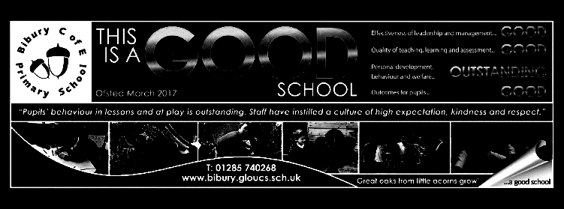

**Welcome to term 6**

Summer term has arrived and we look forward to an exciting final few weeks of learning. Year 6 will be preparing to move to their new schools with induction days to help them get acclimatised.

We are planning a musical this term, based on the discovery of the Tutankhamun’s tomb by Howard Carter. We are not sure as yet how we will share this with parents, but the preparations will provide a context for our work in history where we will be learning about the Ancient Egyptian civilisation. As she is a dance specialist, we are hoping that Miss Spavins will help us to choreograph some Egyptian dance moves to accompany the musical numbers before she leaves us on July 2nd. We will be appealing for materials to help us with this over the next few weeks as the children will also need to make props and costumes.

Towards the end of term, we will have a science and technology week where we hope that, with the easing of restrictions, the children will be able to take part in some group challenges.

Please continue to support your children their key instant recall facts in mathematics as well as encouraging them to read regularly and complete any homework tasks.

Mighty Oaks Term 6 20-2021

**Mathematics**

Revision, practice and problem-solving sessions will continue this term to help secure key mathematical skills. Our ongoing learning for this term will focus on:

|  |
| --- |
| Geometry – calculating missing angles on lines and in shapes.  Properties of 2D and 3D shapes.  Using co-ordinate grids including for translating and reflecting shapes.  Time  **Year 6 in addition**  Nets of 3D shapes  Circles  Statistics (including pie charts) |

**English**

We will begin this term by reading and re-writing some Egyptian myths.

We will then go on to explore biographical writing before finishing with a discussion text, where pupils will be invited to explore the evidence surrounding the death of Tutankhamun and decide how they think he died.

We will continue to explore spellings and ways of learning those challenging words that don’t conform to patterns.

In reading, we will continue to build our comprehension skills. We will also explore ways of recognising genre and precis longer passages to extract the key information.

We will revise the terminology of grammar, particularly focussing on the difference between clauses and phrases.

**Science ‘Growing Pains.**

The ‘circle of life’ – comparing the life cycle of different animals

Changes that occur throughout the human life span.

An investigation into the gestation periods of different animals

The problems that can be faced in old age.

Alongside our science topic, we will be learning in more detail about the changes that occur during puberty.

**Topic –Who were the Ancient Egyptians?**

* Learn about the importance of the Nile in the establishment of the Egyptian civilisation.
* Understand the types of evidence that can be used to reach conclusions about Ancient Egyptian life.
* How different groups of people contributed to Ancient Egyptian achievements.
* Reach conclusions about the Ancient Egyptian people through studying the pyramids.
* Ancient Egyptians’ beliefs about creation and the afterlife.
* The discovery of Tutankhamun’s tomb

Linked to this topic, we will be rehearsing a short musical play – ‘A Glint of Gold’ which is set in Tutankhamun’s tomb.

**R.E.**

For Christians, what kind of king is Jesus?

We will be using the parables to see how Jesus attempted to describe the ‘kingdom of God’ and how Christians might be inspired by Jesus’ teachings.

**P.S.H.E**

Growing and changing

Exploring emotional and physical changes that occur during puberty.

.

**DT**

This term, the children will be exploring materials. We will be linking this with their topic on Ancient Egypt.

**P.E**

Athletics

Striking and fielding games

Our Monday games sessions with Mr. Wyatt also continue this term

**Computing**

Game creation

**Music**

Our music will be linked to our production of ‘Glint of Gold’.