Term 6 Year 1
- Identify one more and one less than any number (to 100).
- Know how many days are in a week and know the order of the days in a week
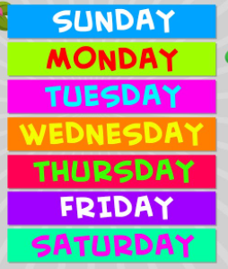
- Know how many months are in a year

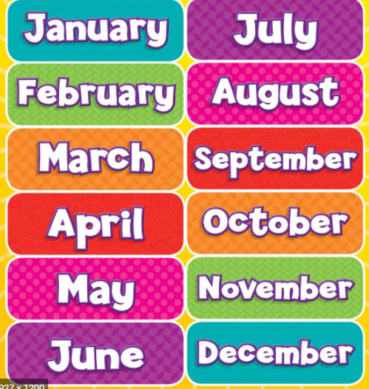
- Know when key events happen (eg. Christmas, know the seasons of the year)
- Make sure your child is secure with all the KIRFS covered this year

