Year 2
Term 5 KIRFS

- Continue to count forwards and backwards in 10s from any number

Eg : 14. 24. 34. 44. 54 …….. 118, 108. 98. 88. 78

- Know multiplication and division facts for the 2, 5 and 10 times tables

Please use the flashcards which are sent home – learn 3 at a time to make this easier for children.
- Know doubles and halves to 20
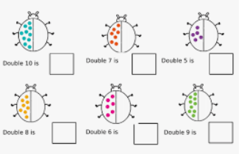
Again flashcards are useful here Double 11 on one side with the answer 22 on the back

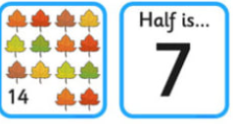
- Know the number of hours in a day. ( There are 24 hours in one day)

- Know the number of minutes in an hour. ( There are 60 minutes in one hour)
- Practice telling the time using an analogue clock. Children need to be able to tell the time to the nearest 5 minutes. This requires daily practice on an analogue clock.
