**Newsletter October 2022**

**Our Christian value this term is:**

**Trust**



# DATES FOR THE DIARY

3/11/2022: Open Morning at Bibury C of E Primary School

7/11/2022: Starting School Sessions (“Little Acorns”) begin

8/11/2022: Sportshall Athletics Yr 5 & 6 at Cirencester College

9/11/2022: Acorns Visit to Birds of Prey at Hunters

13/11/2022: Wreath-laying ceremony at Barnsley Memorial (9.30am) & Remembrance

Day service at St Mary’s Church Bibury (10.45am)

14/11/2022: Kitchen Club – Diwali theme

15/11/2022: School Photos – individual and siblings

16/11/2022: Diwali Dance Workshops

9/11/2022: Height & Weight and Vision Screening (Reception and Yr 6)

30/11/2022: KS2 Hockey session with Helen Pauling

2/12/2022: Nasal Flu Vaccinations (date to be confirmed)

6/12/2022: Barn Theatre Christmas Production

14/12/2022: School Christmas Lunch (Caterlink)

19/12/2022 – 02/01/2023: December Holidays

# ACORN CLASS

Acorns had a very busy end to the term with all the children working hard in all aspects of the curriculum.

In English, the children have produced some excellent reports linked to their work on Life in the Past. They used our model to help them structure and write their reports. We also completed the term with some work on poetry using The Sound Collector as our stimulus.

Our class had a wonderful time at the Cotswold Motoring Museum where we learnt a lot about how transport has changed as well as investigating their huge collection of old toys. The children enjoyed playing with a selection of these as well as looking at a vast array of different toys in the museum. As ever, the children were a credit to the school and thoroughly enjoyed meeting up with their friends at North Cerney too.

Children in the Early Years group are making fantastic progress and have already completed Phase 2 phonics, learning most of the letters of the alphabet and the sounds they make. They have been practising how to read and to write and can now write short captions and read short sentences - Wow !

In PE, the children have made great progress learning how to play hockey which is something new for Key Stage 1 - they have learnt how to dribble, shoot, tackle and defend - well done Acorns !  Progress in swimming continues with most children in the class now able to swim across the width of the small pool with or without a float.

Well done Acorns, you have worked hard this month.

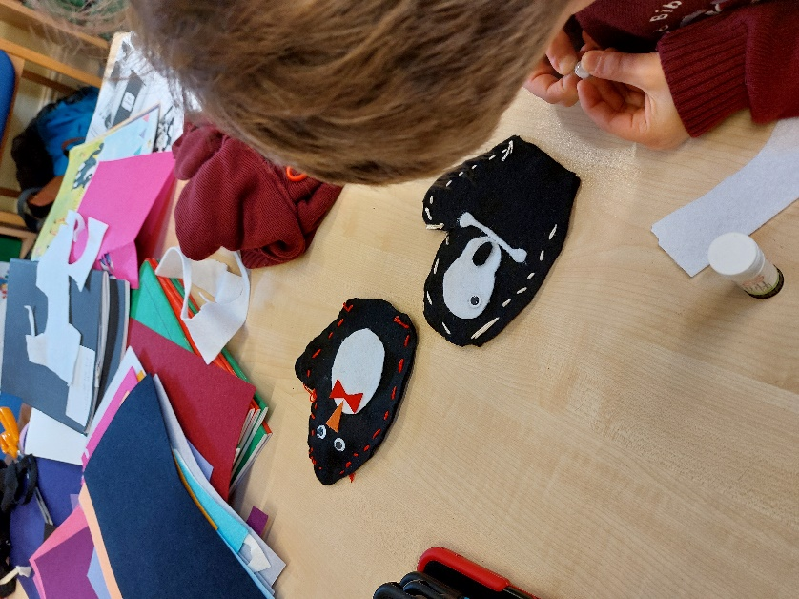 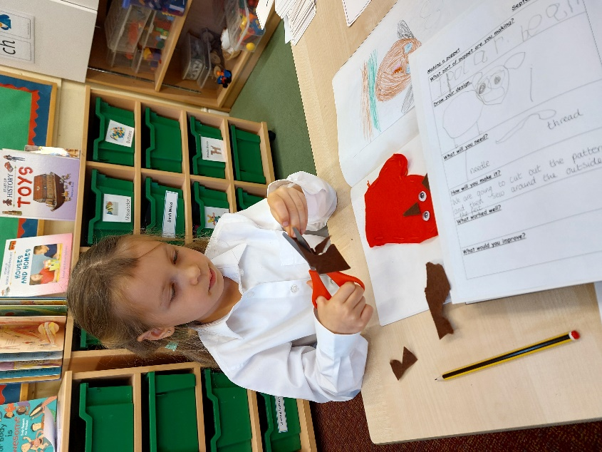

*Acorns class making puppets for Design & Technology*

# OAKS CLASS

Over the last few weeks, Oaks class have been writing instructions in how to defeat a mythical monster. They have needed to think about clear and concise ways to instruct the reader by using imperative verbs, precise adjectives and bullet points to list each instruction.

In Science, Oaks class have been working through a series of intriguing investigations about electricity. They have learnt to classify mains and battery-operated appliances and how to identify the dangers of electricity and have recently been able to create their own simple circuits.

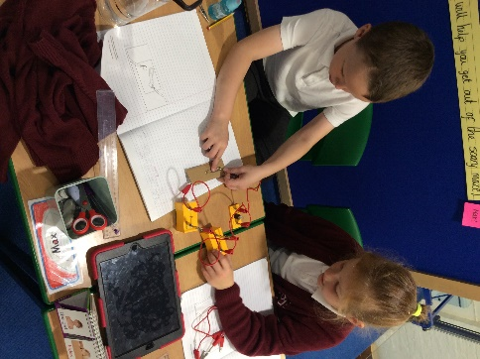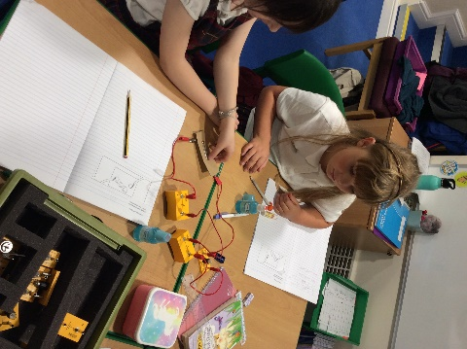

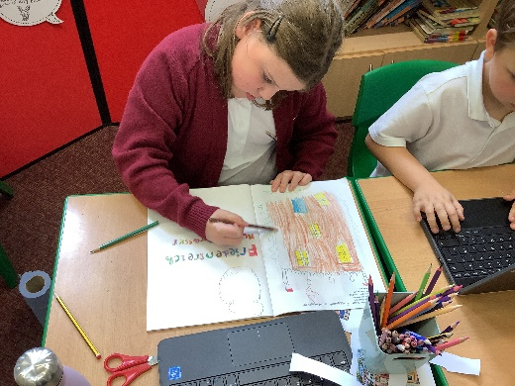**Oaks and Mighty Oaks Classes**

In Art, Oaks and Mighty Oaks have explored our topic ‘Architecture’ even further. They have been recently set with the task of researching the Artist, Friedensreich Hundertwasser, an Austrian artist and architect, and were instructed to create a single or double page spread which illustrated his work.

Oaks and Mighty Oaks have also had the chance to ‘become an architect’ by drawing their own plan view, perspective view and front elevation view of a building of their choice.

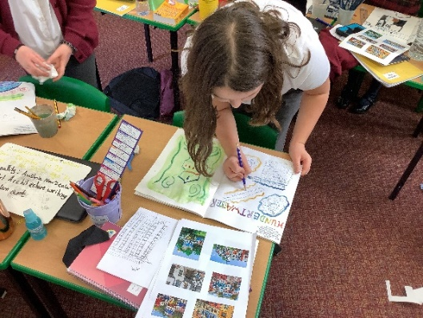

# MIGHTY OAKS CLASS

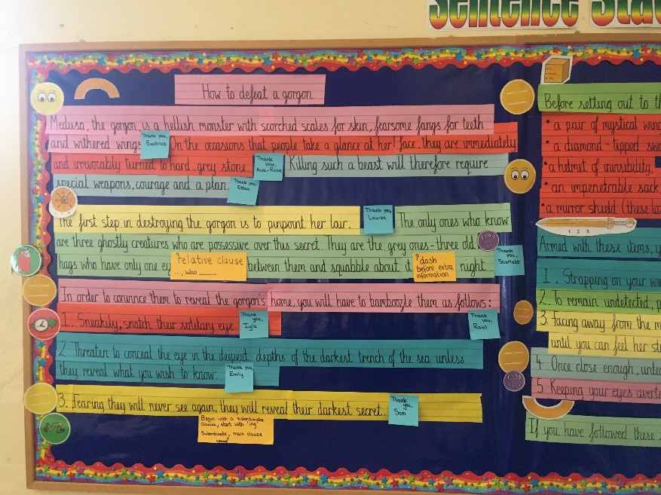The children have all enjoyed listening to Greek myths linked to their topic on Ancient Greece. As a class, they wrote a set of instructions to show how to defeat the gorgon Medusa, and then pupils were challenged to create a monster of their own and write instructions for conquering it. Here is the text that we created together:

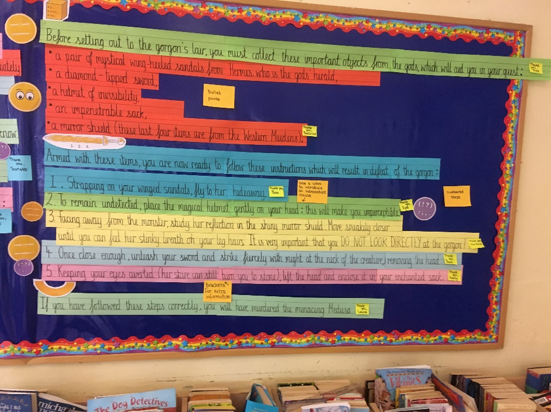

The children have all completed their Maths unit on addition and subtraction, with year 6 also completing their learning on multiplication. Year 5 move onto this next term, with year 6 working on division.

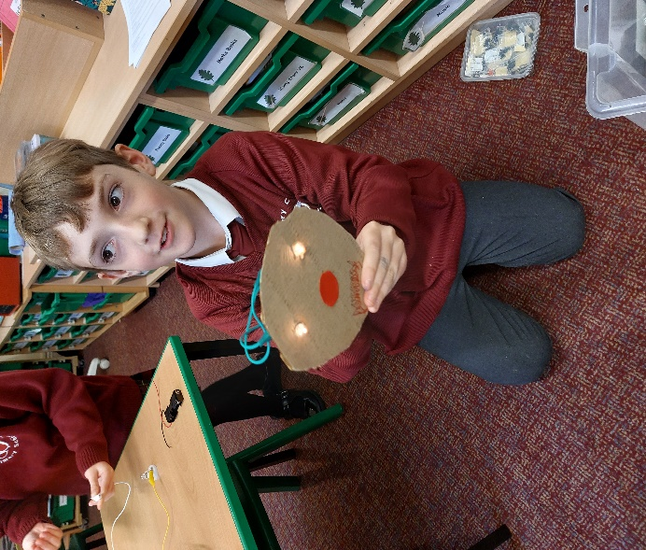They completed their work in Science by creating working ‘toys’ using electricity to power them. Our projects included a burglar alarm, scribbling robots, toys with light-up eyes and a buzzwire game. 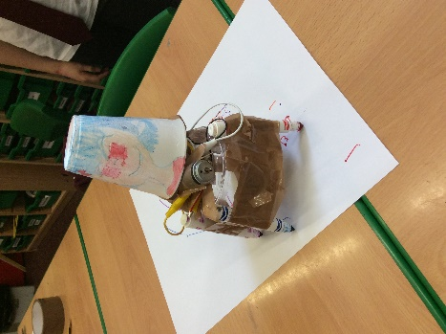

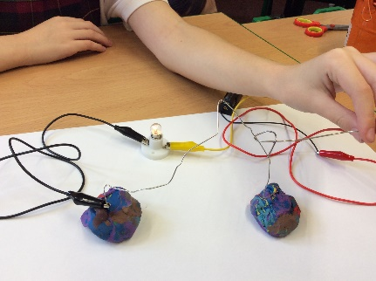

# worship council AND school council

Our Worship Council and School Council representatives for this year have been selected and have received their badges. We look forward to their input into the daily life of our special school.

# YEAR 5 OUTING – “IN THE NET”

On 7th October our Year 5 children attended a performance at Cirencester Primary School. “In the Net” is an interactive play aimed at Year 4 pupils, which focusses on some of the issues around safe Internet use, cyber-bullying and the prevention of exploitation, as well as letting children know where they can go for help and support with regards to cyber-bullying. The play is a memorable way to enhance their safe internet usage and help our young people to stay safe online. (Last year’s performance for our then-Year 4s was postponed due to the actors contracting Covid.)

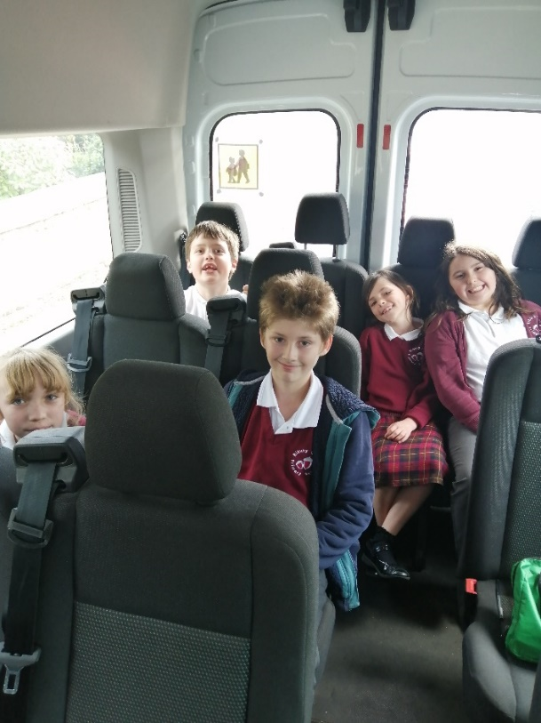

# FROM THE PTA

A poster is attached below with details of the Wreath

Making Workshop, organised by the PTA, to be held at the

school on Friday 2nd December at 6.30pm. For anyone

interested in booking a place, please contact the PTA.

The Rag Bag collection bin at the Bibury Soccer Club

(just off the main road) brings in useful income for

the PTA, so please continue to support the initiative

by dropping off your unwanted clothing, shoes and bags,

and asking your friends and neighbours to do the same!

As you will see from this certificate, the PTA earned

£64.00 from the last collection.

# EARLY MORNING ARRANGEMENTS

From Term 2, KS2 children will join KS1 for early morning playtime when they arrive at school. The playground will be supervised from 8:30am and the bell will ring to start the school day at 8:45am. Children can be supervised in school from 8:00am by prior arrangement.

# OPEN MORNING – 3RD nOVEMBER

Please pass this information on to anyone you think might be interested in attending our Open Morning.

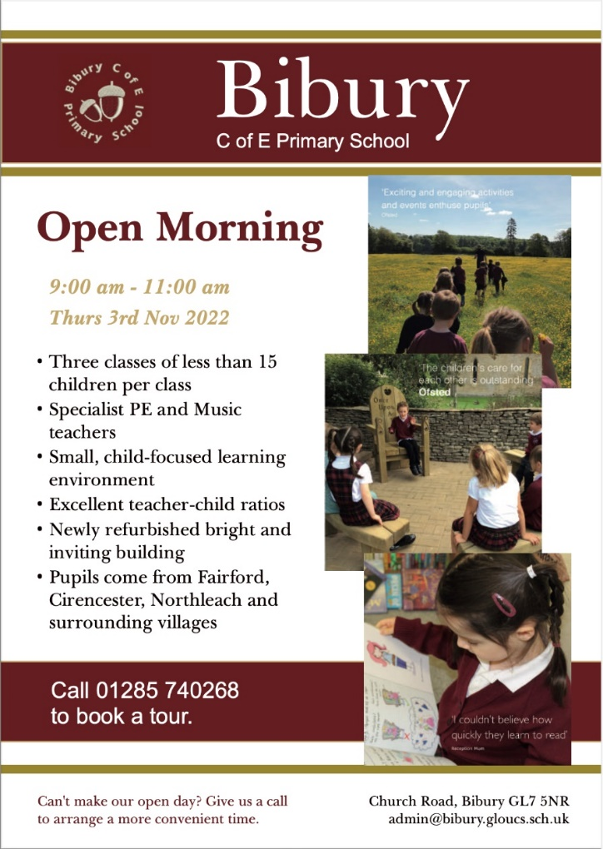

# POPPY APPEAL and remembrance day services

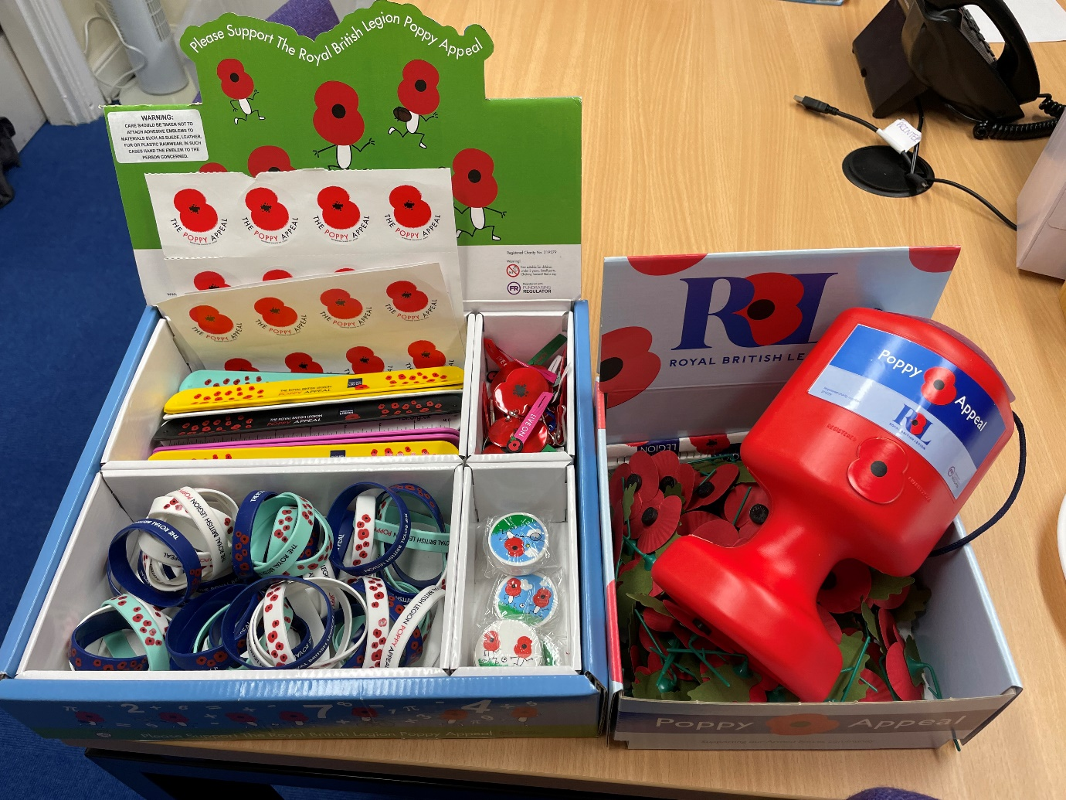

Remembrance Day poppies in aid of the Royal British Legion are now available in the school office. There are also some fun rulers, erasers, wristbands, stickers and zipper-pulls. Please may we suggest donations of £1 or more.

The collection tin and goodies will remain in the office until Friday 4th November, whereafter they will move on to North Cerney Primary Academy. Please be generous!

The wreath-laying ceremony will take place at the Barnsley Memorial on Sunday 13th November at 9.30am. Remembrance Day Service will be held in St Mary’s Church Bibury on the same Sunday, starting at 10.45am.

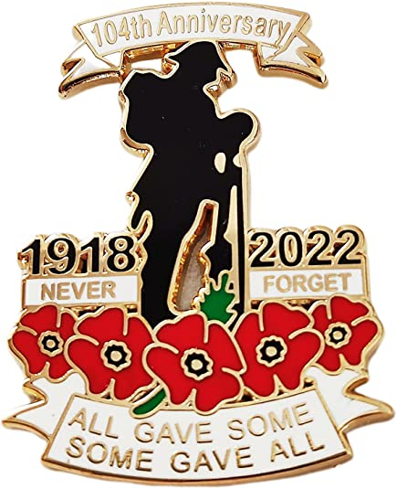

**Spirituality**

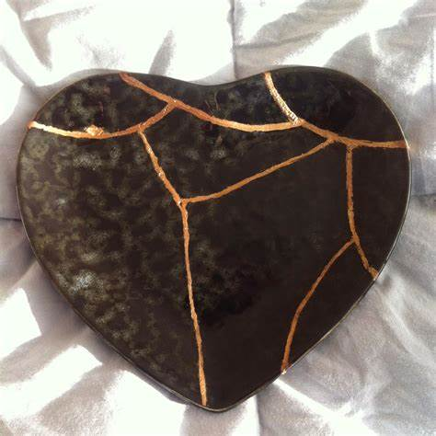

**We are the clay, and you are our potter; we are all the work of your hand.**

**Isaiah 64:8**

We have been helping children to understand and explore spirituality through using the analogy of kintsugi and golden glue.

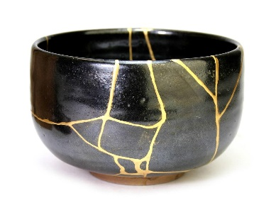

Kintsugi is a Japanese word meaning ‘golden joinery’.

Artists use golden glue to repair cracks bringing unexpected beauty, and in some cases allowing the light to shine through. The repaired put becomes more beautiful than it was when perfect.

We may be beautiful creations … but what can make us expand or crack?

Spirituality can be seen as the golden glue with which we can fill the gaps that may be caused by the ‘ows’, the ‘wows’ and the ‘nows’ of life.

The ‘ows’ are the blows life can bring that can knock the breath out of you.

The ‘wows’ are the moments of awe and wonder, when you want to breathe in and capture the moment, holding it for as long as you can.

The ‘nows’ are every day, ordinary times. These are those times of calm reflection when you are in the moment.

# LITTLE ACORNS – STARTING SCHOOL SESSIONS

These sessions will be starting on Monday 7th November, for children who will be starting their Reception year in September 2023. Please pass this information on to anyone with young children who you think might be interested in joining our special school.



