Term 6 Key Instant Recall Facts for Year 4 | Key Instant Recall Facts to Revise from Year 3
- Know that:  - 1hr = 60 minutes  - 1 min = 60 seconds  - 1 year = 12 months  - 1 week = 7 days  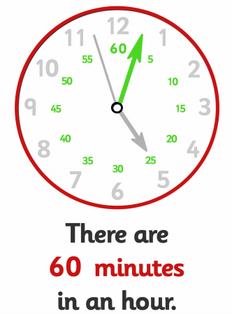  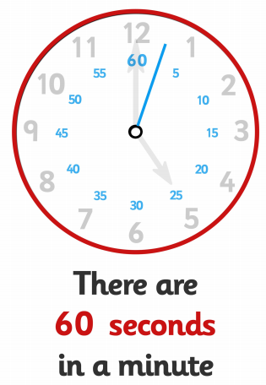 | 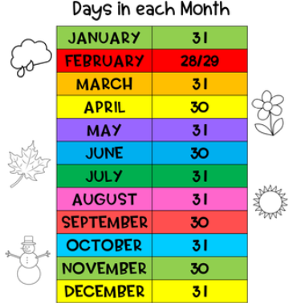  - Know the number of hours in a day and days in each month.  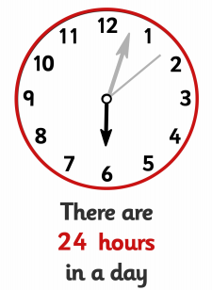  - Know the number of days in a year and a leap year.  - Recognise and name 3D shapes (cubes, cuboids, pyramids and spheres).

