Term 5 Key Instant Recall Facts for Year 4 | Key Instant Recall Facts to Revise from Year 3
- To place tenths and hundredths in decimals on a place value grid.  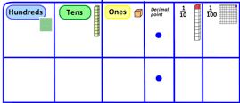  - To divide 1 and 2 digit numbers by 10 and 100.  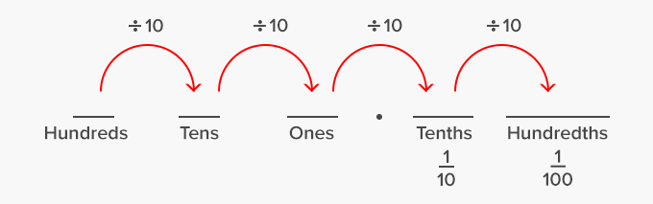  - To add, subtract, divide and multiply money.  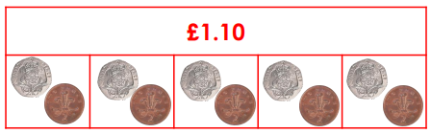  E.g. £1.10 divided by 5 = | 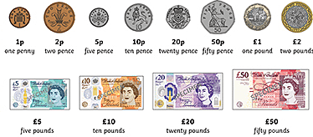  - To recognise pounds and pence and add or subtract money.  - To convert between pounds and pence using the knowledge that £1 is 100 pence.    

