Term 6 Key Instant Recall Facts for Year 3 | Key Instant Recall Facts to Revise from Year 2
- Know the number of seconds in a minute.  - Know the number of days in each month.  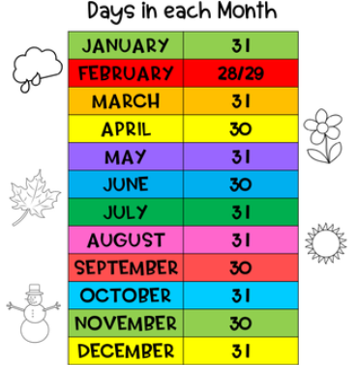  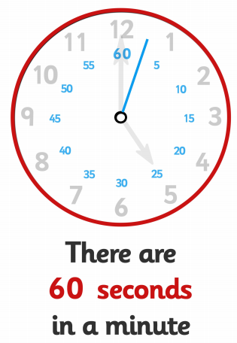  - Know the number of days in a year and a leap year. | - Know the number of minutes in an hour and the number of hours in a day.  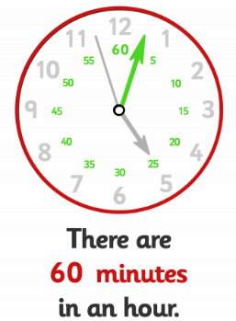  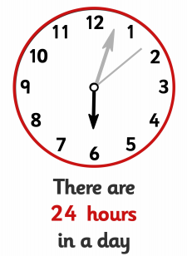  - Recognise and name 2D shapes (rectangles, squares, circles and triangles).  - Recognise and name 3D shapes (cubes, cuboids, pyramids and spheres).

