Term 4 Key Instant Recall Facts for Year 4 | Key Instant Recall Facts to Revise from Year 3
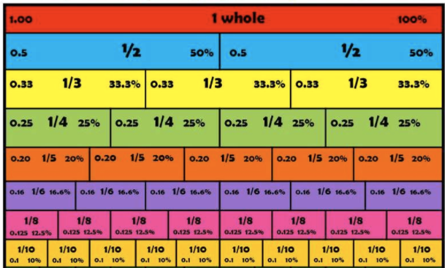  - Know percentage and decimal equivalents to $\frac{1}{2},\frac{1}{4},\frac{1}{5},\frac{2}{5}.\frac{4}{5}$ and fractions with denominators that are multiples of 10 and 25.  - Add and subtract 2 fractions and write the answer in its simplest form using my knowledge of equivalent fractions.  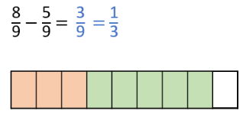  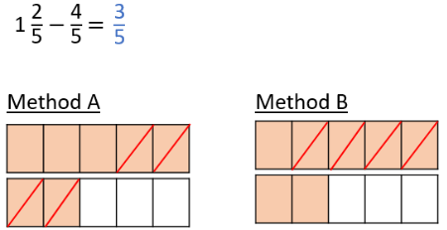 | 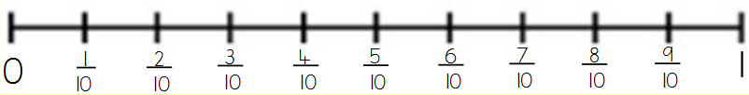  - Count in 10ths.  - Make a whole from fractions e.g. $\frac{2}{2},\frac{3}{3}$ etc.  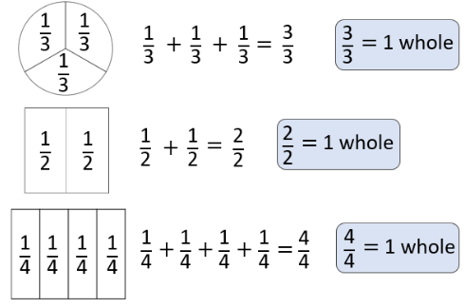  - Add and subtract fractions.  