KEY INSTANT RECALL FACTS FOR TERM 4 year 5
Times tables if not known remain a priority  Here you can see that 40 out of the 100 squares are shaded. This the same as 4 tenths. We know that 4 tenths is 0.4.  You can also see that it is the same as two fifths. | - Know that:  - 10 tenths = 1  - 100 hundredths = 1  - 10 hundredths = 1 tenth  Know decimal equivalents to $\frac{1}{2},\frac{1}{4},\frac{1}{5},\frac{2}{5}.\frac{4}{5}$ and fractions with denominators that are multiples of 10 and 25.  $$\frac{1}{2}$$ $$\frac{5}{10}$$ 0.5  $$\frac{1}{4}$$ $$\frac{25}{100}$$ 0.25  $$\frac{1}{5}$$ $$\frac{2}{10}$$ 0.2  $$\frac{2}{5}$$ $$\frac{4}{10}$$ 0.4  $$\frac{4}{5}$$ $$\frac{8}{10}$$ 0.8  $$\frac{1}{20}$$ $$\frac{5}{100}$$ 0.05  $$\frac{9}{20}$$ $$\frac{45}{100}$$ 0.45  $$\frac{1}{25}$$ $$\frac{4}{100}$$ 0.04  $$\frac{7}{25}$$ $$\frac{28}{100}$$ 0.28  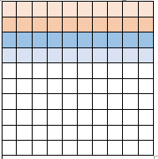
Know the difference between area and perimeter and be able to find the area and perimeter of rectangles. | Perimeter is the distance around the edge of a shape. Find this by adding together the length of each side.  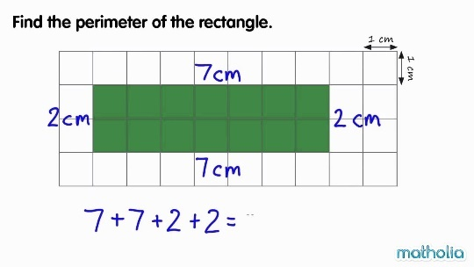  Area is the amount of surface that a shape covers, measured in squares. For rectangles, we remember ‘Area is the squares inside; length and width are multiplied.”  