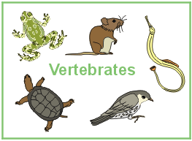
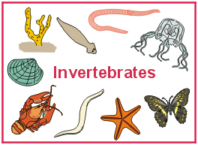
Oaks Science Knowledge Organiser Term 5
Living Things

Key Objectives
- To explain how living things can be classified and how a simple key helps identify them.
- To identify invertebrates with a simple key.
- To recognise that environments change.
- To understand some of the human impacts on specific habitats.
- To be able to classify the five vertebrate groups based on physical features.
- To be able to classify plants as flowering or non-flowering.
- To devise and use a key to identify common trees from their leaves.
Key Vocabulary
classify | To group things so that that they can be identified.
key | A series of questions that helps identify or classify things.
organism | A living thing, animal or plant.
habitat | A place where something lives.
invertebrate | An animal with a backbone.
vertebrate | An animal without a backbone.
insect | An animal with six legs.
mammal | An animal that gives birth to live young.
bird | An animal that flies and has an internal skeleton.
amphibian | An animal with an internal skeleton that lives both in and out of water.
reptile | An animal with an internal skeleton that lays eggs but lives on land.
fish | An animal with an internal skeleton that lives in water and has gills.
flowering plant | One that produces pollen and seeds.
Sticky Facts
- Fish, reptiles and amphibians are cold-blooded.
- Mammals and birds are warm-blooded.
- Non-flowering plants include plants such as conifers, ferns and mosses.
- Flowering plants include all other plants, including most trees, grasses and shrubs. They produce flowers, which produce pollen.

