Spirituality
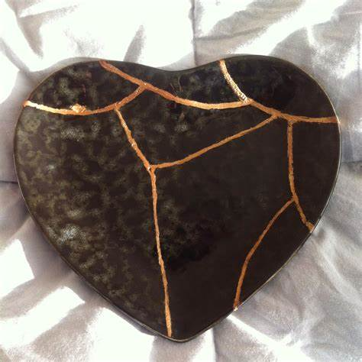

We are the clay, and you are our potter; we are all the work of your hand.
Isaiah 64:8

We have been helping children to understand and explore spirituality through using the analogy of kintsugi and golden glue.
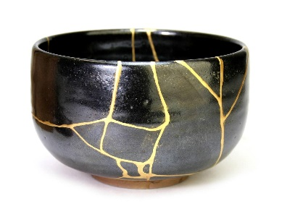
Kintsugi is a Japanese word meaning ‘golden joinery’.
Artists use golden glue to repair cracks bringing unexpected beauty, and in some cases allowing the light to shine through. The repaired put becomes more beautiful than it was when perfect.

We may be beautiful creations … but what can make us expand or crack?

Spirituality can be seen as the golden glue with which we can fill the gaps that may be caused by the ‘ows’, the ‘wows’ and the ‘nows’ of life.
The ‘ows’ are the blows life can bring that can knock the breath out of you.
The ‘wows’ are the moments of awe and wonder, when you want to breathe in and capture the moment, holding it for as long as you can.
The ‘nows’ are every day, ordinary times. These are those times of calm reflection when you are in the moment.

