Term 4 Key Instant Recall Facts for Year 3 | Key Instant Recall Facts to Revise from Year 2
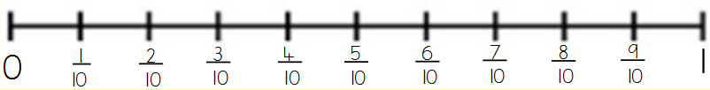  - Count in 10ths.  - Make a whole from fractions e.g. $\frac{2}{2},\frac{3}{3}$ etc.  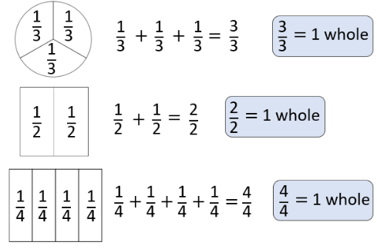  - Add and subtract fractions.  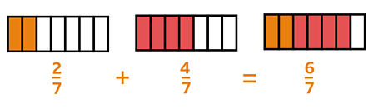  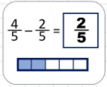 | - To recognise unit and non-unit fractions.  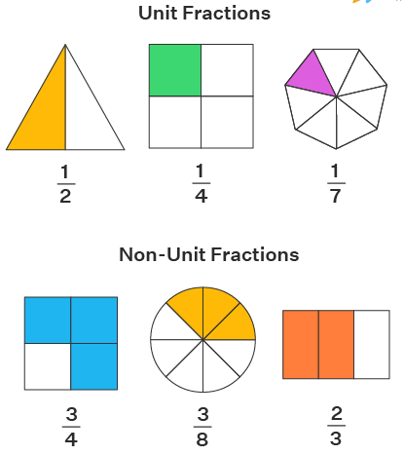  - To draw non-unit and unit fractions as shaded bar models.  