

**Reading at**

**Bibury C of E Primary School**

**Intent**

At Bibury School, we love reading! We want all of our children to not only learn the skills required to ensure they become confident, proficient readers but also encourage them to read for pleasure and information.

**Implementation – KS1**

Our reading journey begins in Reception where children start to learn to read with daily phonics lessons. We recognise the importance of the acquisition of early phonics to reading confidence. We follow the Letters and Sounds phonics scheme where the children learn the initial sounds and how to segment and blend with them. Further details can be found in our phonics statement. They will also have the experience of listening to and joining in with many stories, poems and rhymes being read to them every day. In addition, there is a lovely library and book corner with a great range of texts for them to choose from.

In KS1, we continue our daily phonics lessons every morning. We also begin to have whole class and small group guided reading sessions where all children will have copy of the same text – these can be short stories, extracts from stories, picture books, information texts and poems. During these sessions, we aim to develop vocabulary and comprehension skills.

Alongside other texts, we use the Cracking Comprehension tool which allows access to a range of quality texts and challenging questioning.

From year one onwards, the children are enrolled on the Accelerated Reader program. This enables them to select books that are closely matched to their reading ability, ensuring an appropriate level of challenge to enable them to make progress. On completion of a book, they can take an online quiz which tests their recall and understanding of the text. By reading the books in the scheme (a huge range of well-known classic and modern stories and non-fiction), they will work towards a reading target set by the teacher, for which they can earn certificates and rewards.

**Implementation – KS2**

As the children move into KS2, these guided reading sessions continue. Throughout the year, our children experience a variety of vocabulary-rich, thought-provoking texts. These include a mixture of classic and modern texts as well as non-fiction and poetry. After reading the text (sometimes teacher reads, sometimes pupils, sometimes both) there will be discussions about the meaning of words throughout the text as well as questions focusing on retrieval, inference, prediction and authorial intent. They are also encouraged to make comparisons with other texts they have encountered. As pupils move through the school, they will increasingly provide written answers to these questions.

The teacher will also continue to read daily to the children. This is usually a longer novel, explored over time, which enables all pupils to have access to quality texts that might be beyond their own reading ability.

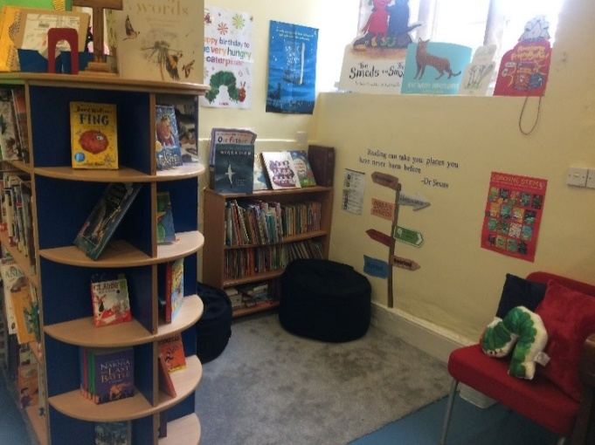We have a lovely library area where children can sit comfortably and quietly whilst they are choosing books.

Children are also encouraged to write and share book reviews on our online learning interface, Padlet.

*Celebrating Reading*

Our recognition of the importance of reading is underlined by our regular celebrations. Reading certificates are awarded to pupils who reach their termly targets, or milestones along the Accelerated Reader pathway. We also have ‘Bookworm of the Term’ award where a child who has demonstrated a real commitment to reading is presented with a beautiful book.

We enjoy sharing our love of books on national days such as ‘World Book Day’ and ‘National Poetry Day’.

We regularly invite authors in to the school, to share their books, talk about their work and inspire the children.

*Beyond the Classroom*

Of course, the reading journey does not stop at school. We encourage all children to read every day at home as this is vital to children’s development as readers. Our pupils are all encouraged to take part in the Summer Reading Challenge run by the library service.

**Impact**

Pupil attainment is measured through the use of the Star Reader online assessment and termly written assessments using Rising Stars.

The systematic teaching of reading skills, together with a promotion of the love of reading for pleasure will produce pupils who are confident and enthusiastic readers who recognise and are able to discuss the value of the written word.

**‘The more you read, the more things you’ll know. The more you learn, the more places you’ll go!”** – Dr. Seuss.