KEY INSTANT RECALL FACTS FOR TERM 2 FOR YEAR 6
Times tables if not known remain a priority. | - Know and recognise all the prime numbers to 19:  2,3,5,7,11,13,17,19  and be able to identify prime numbers up to 100.  In order to do this, you will need to use some of the rules of divisibility that we learned in term 1:  - Multiples of 5 end in 5 or 0  - 2 is the only even prime number, all other even numbers are multiples of 2  - If the digit sum of the number is a multiple of 3, the number divides by 3.  - Know square numbers to 12².  Square numbers are the answers (products) you get when multiplying a number by itself.  e.g. 4 x 4 = 16, so 16 is a square number.  1,4,9,16,25,36,49,64,81,100,121. 144  - Divide 1, 10,100 and 1000 by 2, 4, 5 and 10 (to support reading scales).  1 ÷ 2 = 0.5 10 ÷ 2 = 5 100 ÷ 2 = 50 1000 ÷ 2 = 500  1 ÷ 4 = 0.25 10 ÷ 4 = 2.5 100 ÷ 4 = 25 1000 ÷ 4 = 250  1 ÷ 5 = 0.2 10 ÷ 5 = 2 100 ÷ 5 = 20 1000 ÷ 5 = 200  1 ÷ 10 = 0.1 10 ÷ 10 = 1 100 ÷ 10 = 10 1000 ÷ 10 = 100  - Know the order of operations (BIDMAS).  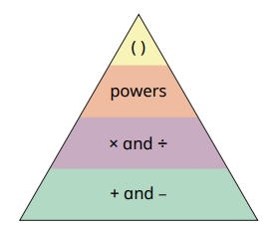  Brackets, indices, division and multiplication, addition and subtraction

