Year 5 Term 6 Key Instant Recall Facts
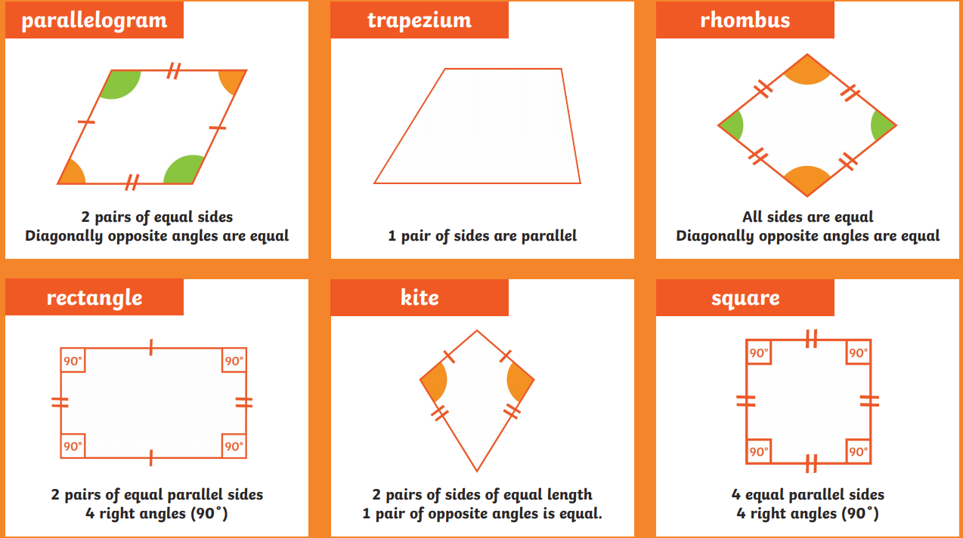
Geometry – key facts  There are 360º in a full turn.  There are 180º on a straight line.  There are 90º in a right angle. | In order to solve problems with shape and angles, you will need to remember these key facts about degrees.  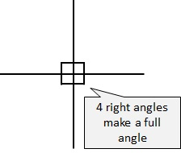  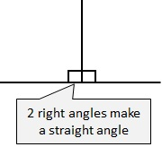  To help remember this, you can use your knowledge that a right angle is 90º. There are 2 right angles to make a line, and 4 right angles in a full turn.
Be able to identify these quadrilaterals by their properties:
- Square
- Oblong (rectangle)
- Parallelogram
- Trapezium
- Rhombus
- Kite

