Knowledge organiser for Acorns Class Term 5 2021-22
Religious Education
Judaism: Who is Jewish and how do they live? (part 2)
Key vocabulary
Judaism | The faith of Jewish people
Hanukkah | The Jewish festival of lights, which takes place in December
Sukkot | The Jewish festival of harvest
Celebration | A joyful time where people remember something good.
Oil lamp | A light that comes from burning oil.
Miracle | Something that happens that should be impossible
Latke | Crispy potato pancakes eaten at Hanukkah
dreidl | A four-sided spinning top used as a game during Hanukkah
sukkah | A shelter built for the festival of Sukkot

Key Information that you should know by the end of the unit
- Judaism is the name of the religion followed by Jewish people.
- The story of David and Goliath is in the Old Testament of the bible and tells of David’s bravery
- Jewish people celebrate different festivals through the year.
- Hannukah is a Jewish festival where Jewish people remember the victory of Judah the Maccabee and the miracle of the oil lamps that burned for 8 days.
- The Jewish harvest festival is called Sukkot. During Sukkot, Jewish families will put up a shelter in their garden where they eat all their meals.
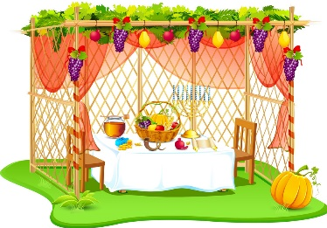
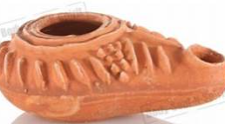
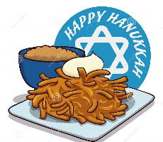
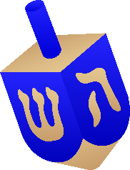

Sukka dreidl latke oil lamp
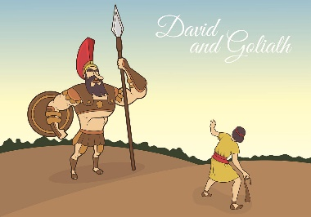

David and Goliath

