Term 4 for Year 1
- Continue to count in 2s to 20, 5s to 50 and 10s to 100.
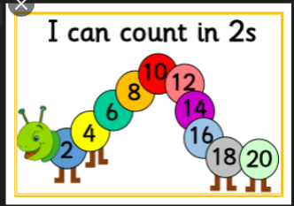 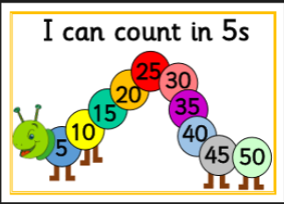’

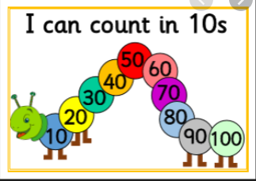
- Continue to count to and across 100, forwards and backwards, from 0, 1 or any number.

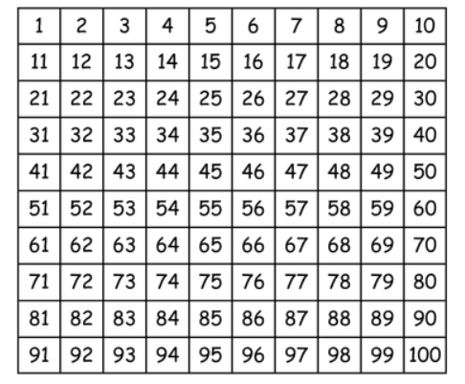
- Continue to count, read and write numbers to 100 in numerals.

- Know the days of the week in order
- Know the months of the year in order. ( Recap from EYFS year)

