Knowledge organiser for Acorns term 1
Religious Education
Islam – part 1: Who is Muslim and how do they live?
Key vocabulary
Islam | The name of the religion followed by Muslims
Muslim | A person who follows the religion of Islam
Allah | The name given to God in Islam
Muhammad | A prophet – the founder of Islam
The Quran | The holy book of Islam
Shahadah | The words that Muslims say to show their beliefs
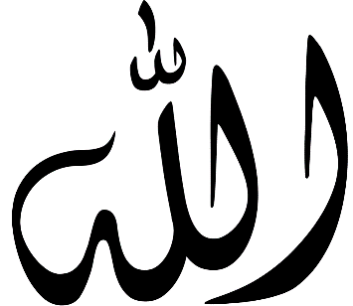
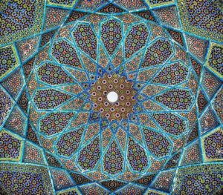

Example of Arabic writing – this is the word ‘Allah’.
Example of Islamic patterns decorating a mosque.

Key Knowledge
- Muslims believe in one God, called Allah in Arabic.
- Muslims believe that Allah spoke to a man called Muhammad giving him the words of the Quran.
- The Quran is written in a language called Arabic
- Muslims all say the Shahadah daily. The words of the Shahadah are in Arabic. They translate as, “There is only one called Allah and Muhammad is his messenger’. These are the first words that are whispered to a new baby.
- Muslims never have pictures of Allah or Muhammad. Their holy places, called mosques, are often decorated with patterns.
- Muslims have 99 names for Allah. Each name shows one of his characteristics.
- Muslims use stories about the way that Muhammad lived to help them live their own lives well.

