Year 5 Term 5 Key Instant Recall Facts

To convert between units of measure, pupils need to know the relationship between different metric units. | - 1cm = 10mm  - 1m = 100cm  - 1km = 1000m  - 1kg = 1000g  - 1l = 1000ml
In order to solve problems relating to time, they need to know the length of key time periods.  If you are finding it hard to remember how many days are in each month, using your knuckles might help. All the ‘sticking up, knuckles represent 31 days, the others are all 30 apart from February.  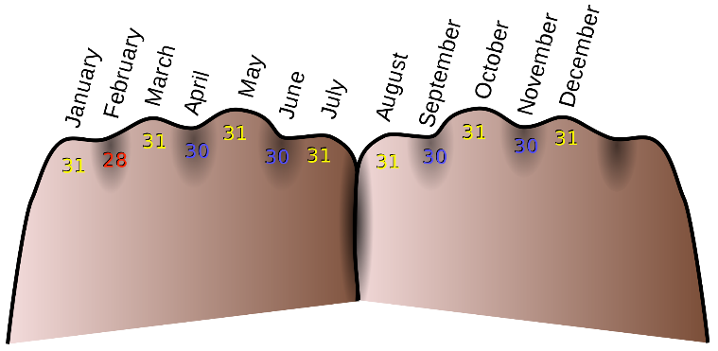 | - 1hr = 60 minutes  - 1 min = 60 seconds  - 1 day = 24 hours  - 1 week = 7 days  - 1 year = 12 months  If not already secure, make sure you also know how many days are in each month.  Thirty days have September,  April, June and November  All the rest have 31,  except February  Which has 28 days clear  And 29 days each leap year.

