Term 3 in Acorn Class – Key Stage 1
Who was Mary Anning?  Born in 1799 in Lyme Regis, Dorset, Mary Anning is famous for discovering a species of ichthyosaur. We will be finding out about her life, the impact of her discoveries and how historians find out about the past using sources. We will also find out more about the fascinating world of dinosaurs and the work of palaeontologists. | 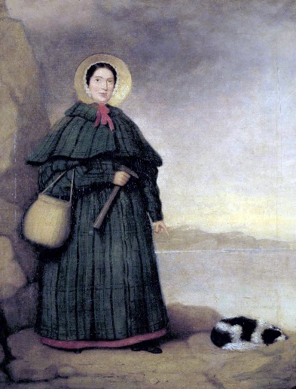  1799 - 1847
Maths  Year 1 will be focusing upon addition and subtraction within 20 before moving on to numbers to 50. Year 1 will learn to count in 2, 5 and 10 this term.  Year 2 will consolidate their calculation skills in addition, subtraction, multiplication and division before moving on to 2D and 3D shape. In the latter half of the term, Year 2 will explore fractions of shape and fractions of quantity. | Celebrations and Changes  In Science we will take a look at how we celebrate Christingle and Chinese New Year observing the use of food and of light. We will then move on to looking at sources of light, how daylight hours change over the year, how shadows are formed and how some materials are more translucent than others.
English  We will be looking at how to write instructions this term using bullet points and step by step planning. We will then move onto planning and writing a narrative with five parts based upon a book called The Monster who ate Darkness. We will end the term with some poetry based upon feelings. | Grammar and Spelling  We will be looking at suffixes this term in particular ed, ing and er endings for Year 1 (pulled, pulling)  Year 2 will focus on the suffixes ment, ness, ful and less ( eg enjoyment, sadness, colourful, fearless)

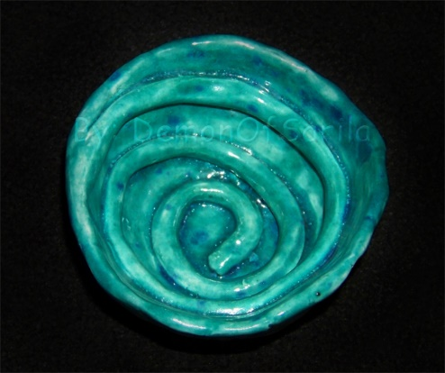 | Art  We will be exploring sculpture this term in particular the use of clay.  We will explore clay techniques including the creation of coil pots before creating a dinosaur sculpture using air drying clay.
RE  Mrs Dearsley will be exploring what Christians believe God is like. We will be exploring how Christian values reflect beliefs in God and his son, Jesus. | Music  We will be listening to blues music this term. We will be learning to find the pulse by moving our bodies to music. We will also learn about pitch and sing new songs. In addition, we will learn to improvise using glockenspiels.
IT  We will be exploring how to create an animation using Purple Mash. Your child will be able to login at home using their passwords in order to show you their work or maybe do some more work on it at home. | PE  We will be linking our Christian values to sport this term with an extra sports coach on Thursdays, Mr Andrew  On Fridays, Mr Peters will continue with multi-skills as usual.
French  Mrs Campbell will continue to introduce basic spoken French using games and activities every Friday afternoon  PSHE  We will be looking at relationships with friends and family and how these change as we grow. | P4C ( Philosophy for Children)  As part of the DGAT family of schools, we will be introducing this element to our curriculum this term. We will be encouraging questioning and some deep thinking – ideal for our more curious learners !

Term 3 in Acorn Class – EYFS
What were dinosaurs ?  We will be exploring the fascinating world of dinosaurs this term. We will use this as a vehicle to examine different environments and animals. We will also join Key Stage 1 in learning about Mary Anning who was the first person to discover an ichthyosaur. | 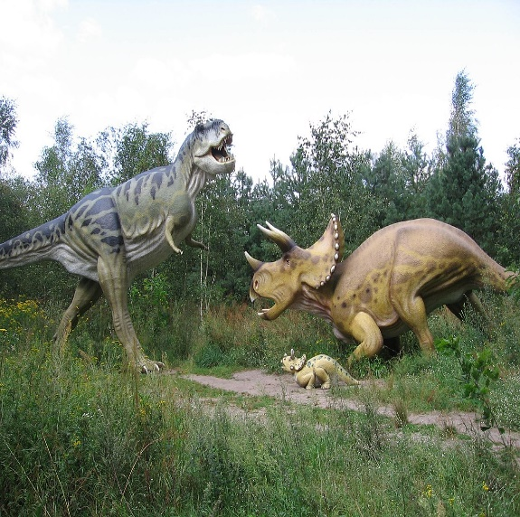
Maths  We will continue our work with dinosaurs and introduce the idea of measurement this term. Children will compare dinosaurs by height, length and weight.  We will also continue our work on understanding numerals to 10 as well as the language of addition and subtraction.  Please support your child to correctly identify numbers 6 – 10. If they can already do this, please work on numbers to 20. | Understanding the World  In Science we will join Key Stage 1 learning about sources of light, how daylight length changes with the seasons and how shadow puppets can be made. We will also explore which materials are best for making a dark, dark cave. In addition, we will be looking at how food plays a role in celebrations and we will be exploring how our senses help us enjoy Christingle and Chinese New Year
English  We will be developing our writing skills this term with the aim of writing short captions or sentences.  We will continue to listen to stories daily in order to answer questions about setting, character and plot. | Phonics  We will continue to learn more sounds from Phase 3 phonics this term. Please look out for these sounds in your child’s red book.  Tricky words will be sent home so that you can practice these also.

Expressive Art
We will be exploring sculpture this term in particular the use of clay.
We will explore clay techniques including the creation of coil pots before creating a dinosaur sculpture using air drying clay.
People and Communities  Mrs Dearsley will be exploring what Christians believe God is like with Key Stage 1. Children in EYFS will focus upon being sensitive to the opinions of others and being aware that different communities share similarities and differences. | Music  We will be listening to blues music this term. We will be learning to find the pulse by moving our bodies to music. We will also learn about pitch and sing new songs. In addition, we will learn to improvise using glockenspiels.
Technology  We will be exploring the Purple Mash site using Mini-Mash, a programme designed for EYFS. The children will be learning how to navigate around these pages to complete tasks. | PE  We will be linking our Christian values to sport this term with an extra sports coach on Thursdays, Mr Andrew.  On Fridays, Mr Peters will continue with multi-skills as usual.
French  Mrs Campbell will be developing basic vocabulary through games and activities as well as strengthening the following skills : listening and attention, self confidence, fine motor control including cutting and assembling skills.  PSHE  We will be looking at relationships with friends and family and how these change as we grow. | P4C ( Philosophy for Children)  As part of the DGAT family of schools, we will be introducing this element to our curriculum this term. We will be encouraging questioning and some deep thinking – ideal for our more curious learners !

