Key Instant Recall Facts for Year 2 (KIRFS)

Term 1
- Count forwards and backwards in 2s and 5s from 0. (Recap from Year 1)
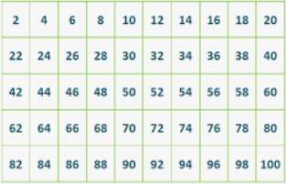

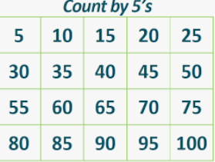

- Know number bonds to all numbers within 10. (Recap from Year 1)
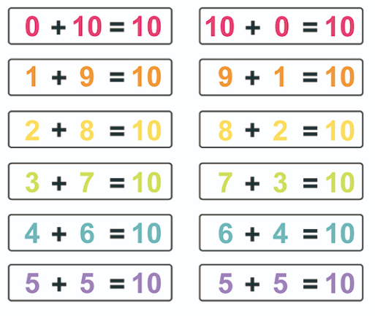

- Count forwards and backwards in 3s from 0.
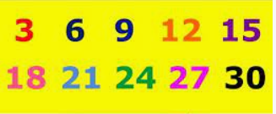

- Continue to count to and across 100, forwards and backwards, from 0, 1 or any number. (Recap from Year 1)
