Year 1
Term 5 KIRFS
( Key Instant Recall Facts)
- Continue to count in 2s to 20, 5s to 50 and 10s to 100.
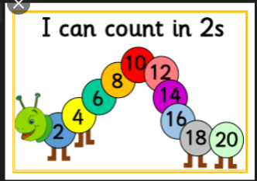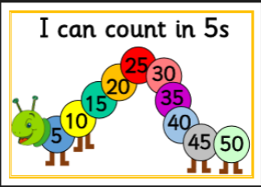
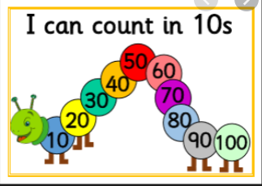
Not all children in Year 1 are secure with counting in 5’s particularly

- Continue to count to and across 100, forwards and backwards, from 0, 1 or any number.
- Continue to count, read and write numbers to 100 in numerals.
- Identify one more and one less than any number (to 100).
- Recap working out number bonds to all numbers within 10.
