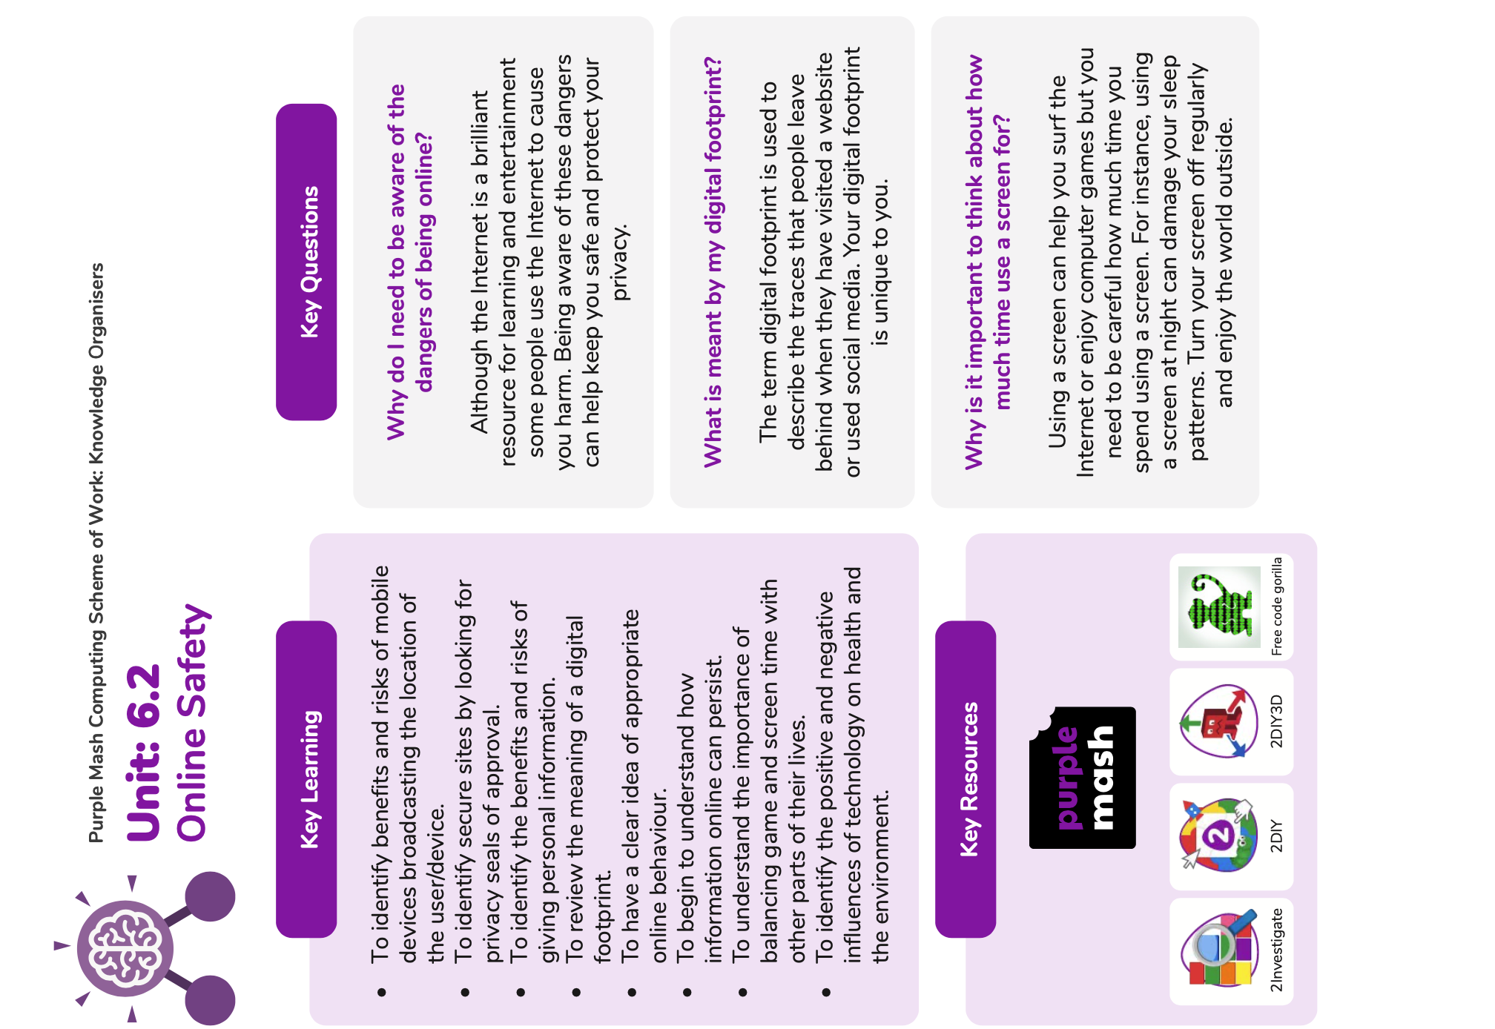**Computing Term 1 Knowledge Organiser – Online Safety and Databases**



