Term 6 EYFS
- Be able to recall all numbers bonds to 5 without needing to count
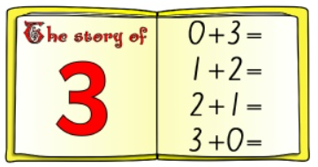

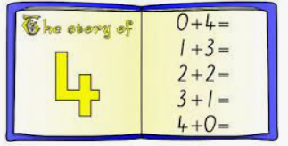

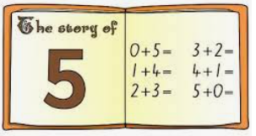
The best way to learn these is to use small objects or lego brick
Practise making the bonds for 3, 4 and 5 until your child can recall them without needing to use the objects. When your child can do this without using objects or fingers, it shows that they have a secure mental image of these number bonds.
- Recognise ordinal numbers (1st, 2nd, 3rd)
- Say to your child – who is first, who is second, who is third when opportunities arise

