Term 4 for Year 2
- Continue to count forwards and backwards in 10s from any number

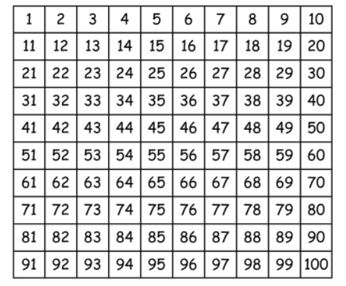
- Recognise odd and even numbers to 100
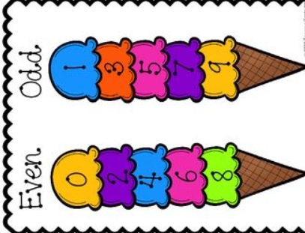
- Know multiplication and division facts for the 2, 5 and 10 times tables.
Remember that the division facts have been learnt too
So If you know 2 x 6 = 12 you also know that 12 2 = 6

- Know doubles and halves to 20.

It is important that children are familiar with the terms double and half and that they can link this to their 2 times tables
