

**Writing at**

**Bibury C of E Primary School**

**Intent**

Writing is a key skill that underpins learning across all other areas of the curriculum. At Bibury School we aim to provide a thorough education in all aspects of writing in order to ensure that all pupils have a ‘toolbox’ of skills and techniques which they can use to express their ideas and understanding in a coherent and creative way.

Our approach to writing therefore includes the following aspects:

* Developing competency in phonics, word/spelling structure. (see also phonics document).
* Developing handwriting skills to ensure fluency and coherence.
* Developing a sound understanding of a full range of punctuation and when to deploy this correctly and effectively.
* Widening pupil vocabulary to allow for precision of expression.
* Developing a sound understanding of grammatical structures and the purpose for which they are used.
* Understanding the structure and language of different writing genres in order to write appropriately to purpose.
* Strategies for editing and revising work.
* Opportunities for creative writing and to help pupils develop a love of writing and pride in their accomplishments.

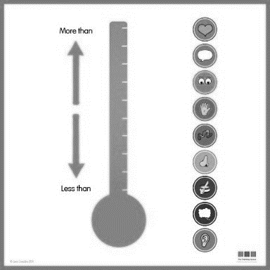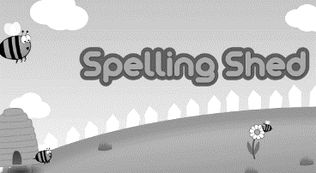

**Implementation**

Spelling

Spelling begins with the structured teaching of Letters and sound phonics in EYFS and KS1 alongside tricky words. Specific spelling patterns are then explored as set out in the National Curriculum document.

In Key Stage 2, children continue to practise spellings daily. Resources are taken from Rising Stars and Literacy (Spelling) Shed. Pupils are encouraged to check their own spelling using a dictionary and the teacher will note any errors to be addressed - a task which pupils will then undertake independently, either under the piece of work or by copying the words into their handwriting books for further practice.

All pupils have access to online spelling support software (Nessy or Spelling Shed) which they can use at home. Parents are informed of weekly spellings through homework so that they can support with practice.

Intervention groups (phonics, speed spell and spelling rules) provide targeted support for groups and individuals where need is identified.

Handwriting

We use the Nelson handwriting scheme which enables pupils to build up their writing skills, beginning with patterns and letter formation in EYFS and building to stylish cursive handwriting in year 6. The correct pencil grip is taught in Acorns class, often supported with tripod pencil grips. We continue to provide these both Oaks classes where required.

Once pupils achieve a neat, joined style, they are rewarded with a ‘pen licence’ from which point they write with pen, rather than pencil.

Alongside handwriting, we encourage pupils to take pride in the presentation of all written work, by crossing out neatly and using rulers for underlining.

Specific interventions are provided for those pupils who are struggling with their handwriting skills.

‘The Write Stuff’ approach to writing

Whilst our long-term plans set out all the grammar and punctuation objectives and our teaching timetable for focussing on these, skills are used in context throughout the year, using ‘The Write Stuff’ strategy pioneered by Jane Considine. Using this vocabulary-rich approach, pupils engage in the gathering of words and phrases in order to write using the ideas for writing (the FANTASTICs), a range of tools (GRAMMARISTICs) and ‘writerly’ techniques (BOOMTASTICs). Writing is highly modelled in chunks to reinforce sentence constructions and enable high quality outcomes. These ‘sentence stacking’ sequences lead to the production of entire collaborative texts and are followed by periods of independent writing where pupils can demonstrate the skills that they have learned. These ‘Write Stuff’ units of study are supplemented by ‘workshop lessons’, where teachers explore the use of grammar and punctuation tools to further develop understanding and competence.

In EYFS, ‘The Write Stuff’ has a focus on the delivery of vocabulary rich talk in order that the children are exposed to a wide range of vocabulary. Our objective in EYFS is to encourage and support the children to use this vocabulary in their talk and subsequently in their own independent writing.

Writing for different purposes

In addition to the specific teaching of writing skills, our long-term planning includes regular teaching of the layout and language features of different types of writing. We ensure that this includes both fiction and non-fiction, using quality texts as examples and based on our topic work where there is a natural and useful link.

Throughout all writing tasks, pupils are encouraged to check and edit their own work both during and post task. In KS2, post task editing is shown in purple pen.

To provide genuine purposes for writing, we encourage pupils to enter their written work into competitions such as the annual Soroptemist challenge. Pupils in Key Stage 2 will also write thank you letters to visitors, persuasive letters to the head or governor and recounts for the school newsletter.

**Impact**

SWST spelling tests are carried out twice yearly in order to assess children’s progress and achievement.

Pupils progress towards their writing targets is noted in ongoing assessments, which are recorded on Target Tracker. In addition, the achievements of pupils in years 2 and 6 is regularly measured in independent extended writing tasks against end of key stage expectations.

By providing targeted and specific teaching of skills in context and opportunities for creative writing, we produce young people who are competent and independent writers who understand what it means to be an ‘author’ and who take a genuine pride in their written work.

