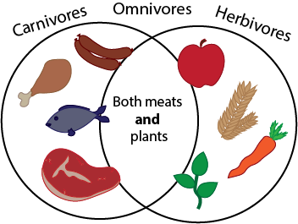
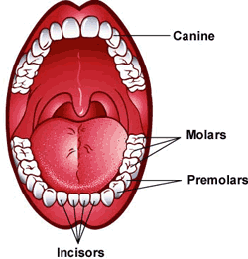
Oaks Science Knowledge Organiser Term 4
Teeth and Eating

Key Objectives
- To classify and identify different types of teeth and their functions.
- To recognise how and why we must take care of our teeth.
- To describe the functions of parts of the human digestive system.
- To recognise what a food chain represents.
- To construct and interpret a variety of food chains.
- To identify producers, predators and prey.
- To make observations and record findings using scientific language and labelled diagrams.
Key Vocabulary
molar | A tooth for grinding food at the back of the mouth.
incisor | A tooth for biting food, at the front of the mouth.
canine | A pointy tooth for gripping food.
enamel | The hard covering of the tooth.
decay | What happens when teeth aren’t cared for properly.
digestion | Breaking down food.
oesophagus | The scientific name for the food pipe.
stomach | A bag of muscle used in the first part of digestion.
small and large intestine. | Small: The thin tube where broken down food is absorbed.  Large: Absorbs water and stores undigested food.
carnivore | Animals such as lions whose main way of getting food is to kill and eat other animals.
herbivore | Animals such as cows that mainly eat plants.
omnivore | Animals, like you, that eat both plants and meat.
Sticky Facts
- The oesophagus is the food highway that takes your food from your mouth down into your stomach so that digestion can begin.
- The stomach is filled with powerful acids that break down the food into smaller pieces. It also lets us know when we are hungry.
- The main job for the small intestine is to absorb nutrients and minerals from food. In fact, 90% of food absorption takes place here, making it our main digestion location.
- The outside of our teeth are covered with enamel and the inside have blood vessels and nerves.

